Betty Ann Labauve
February 24, 1939 – June 9, 2019

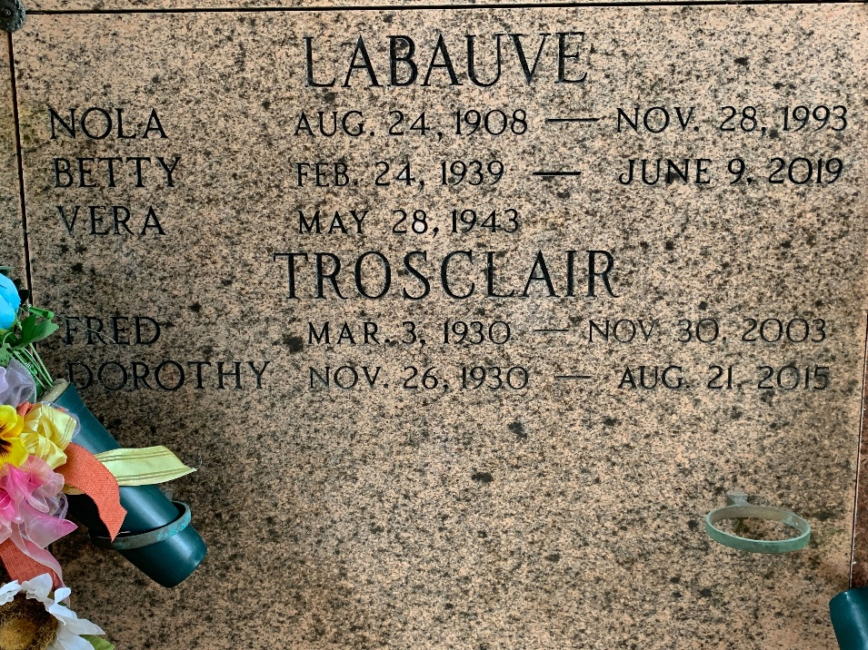
Photo by Team T-Lo

Betty Ann LaBauve, age 80, passed away on Sunday, June 9, 2019. She was a resident of LaPlace, LA. She is survived by her sisters, Vera LaBauve, Linda Ordoyne (Alton), and Elsie Melancon (James).
She was preceded in death by her parents, Joseph and Nola LaBauve; brother, Ray LaBauve, Sr.; and sisters, Shirley Cambre (Edward), Dorothy Trosclair (Fred, Jr.), and Beverly Tassin (Nobby).
A graveside service will be held on Thursday, June 13, 2019 at 10:00am at St. Peter Catholic Cemetery in Reserve, LA. Rose Lynn Funeral Services is in charge of the arrangements.

Rose Lynn Funeral Home, Lutcher, Louisiana

