Vera Ann Labauve
May 28, 1943 – November 5, 2023

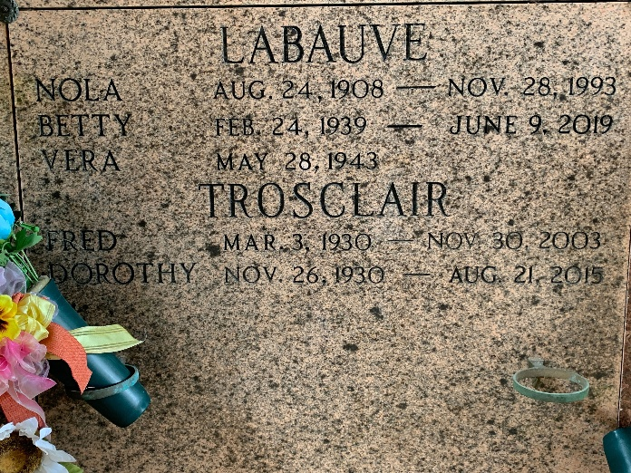
Photo by Team T-Lo

Vera Ann LaBauve, age 80, passed away on Sunday, November 5, 2023. She was a resident of LaPlace, LA and recently resided in Lutcher, LA.
Predeceased by her parents, Joseph and Nola LaBauve; and her siblings, Shirley Cambre (the late Edward), Dorothy Trosclair (the late Fred, II), Elsie Melancon (the late James), Beverly Tassin (the late Nobby), Betty LaBauve, and Ray LaBauve, Sr. (Joyce and first wife the late Myrna).
She is survived by Linda Ordoyne (the late Alton) and numerous nieces and nephews. Vera had a sweet and playful soul. She loved and cared for all her nieces and nephews and would often play games and complete puzzles with them. She loved cooking and put a lot of love and passion into each meal she prepared for her family.
Relatives and friends are invited to attend the Graveside Service at St. Peter Cemetery, 1550 Hwy 44, Reserve on Thursday, November 9, 2023 at 10:00 a.m.

Rose Lynn Funeral Home, Lutcher, Louisiana
November 7, 2023

