Dorothy Marie (Duhe) LaBranche
November 4, 1927 – June 27, 2018

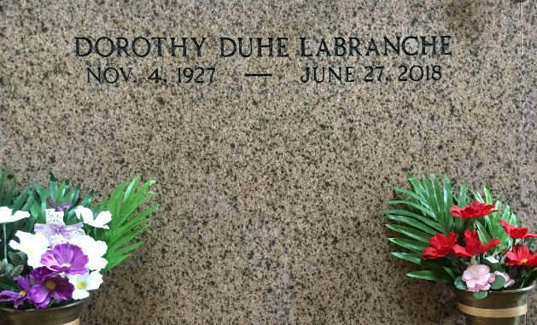
Photo by Team T-Lo

Dorothy "Dottie" D. LaBranche, born November 4, 1927, entered into eternal rest June 27, 2018. She is survived by her daughters, Diana Marse (Kevin) and Joanne Weber (Nolan), daughter-in-law, Robin LaBranche, and sisters, Yvonne Richoux and Catherine Webre. She is also survived by six grandchildren, Brandy Quin (Tommy), Brandon Weber (Nicole), Jason Marse (Kris), Matthew Weber (Amy), Jessie Gregoire (Josh), and Chad LaBranche and 12 great grandchildren.
She is preceded in death by her loving husband, Murphy LaBranche Sr., son Murphy "Jay" LaBranche Jr., brother Lloyd and Alton Duhe, sister Loraine LaBranche, and her parents Sidney and Leoda Duhe.
Dottie was a beloved caregiver, was very creative and loved to crochet. Most of all she loved spending time with her family.
The family would like to thank Louisiana Hospice and Palliative Care for their compassion during this time.
Relatives and friends are invited to attend a visitation at St. Joan of Arc Catholic Church in LaPlace, LA on Monday, July 2, 2018 beginning at 9:30 AM with Mass of Christian Burial to be held at 11 AM. Burial to follow services at St. Peter Cemetery in Reserve, LA. Condolences may be expressed at www.HCAlexanderfuneralhome.com.

The New Orleans Advocate (LA)
Jun. 29 to Jul. 2, 2018

