Joseph C. LaBranche
July 12, 1917 – March 1, 2002

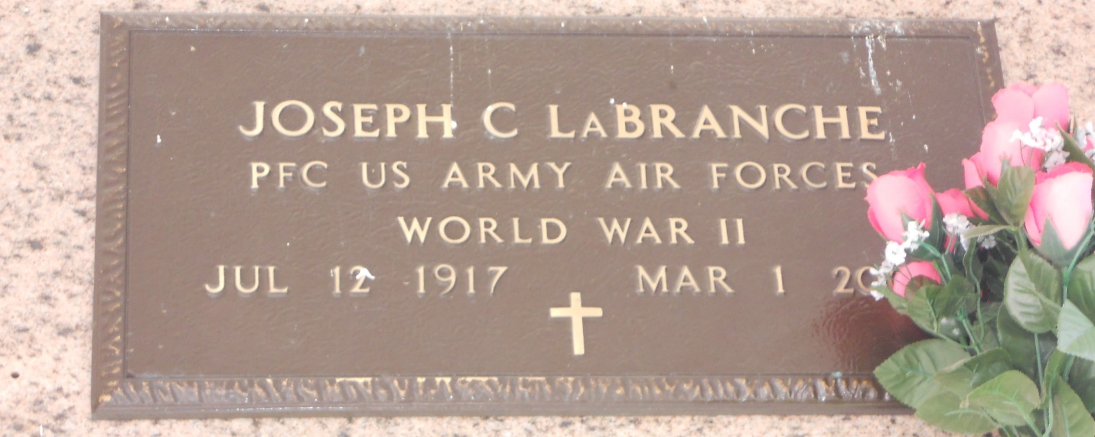
Photo by Team T-Lo

Joseph C LaBranche, on Friday, 1 Mar 2002, at age 84 years, a native and resident of Laplace, Louisiana. Husband of the late Margaret Champagne LaBranche and son of the late Leopold and Amelie Perilloux LaBranche. He was the father and father-in-law of Carl and Penny LaBranche of Garyville, Louisiana and the brother of Mae Granier and Ella Foret of Laplace and the late Beline Schexnayder, Pauline Vicknair, Paul, Earl and Henry LaBranche. Services were Manday 4 Mar 2002 at St Joan of Arc Catholic Church, Laplace with interment in St Peter Church Cemetery, Reserve, Louisiana.
The Times-Picayune, New Orleans, Louisiana
3 Mar 2002

