Leopold Michel LaBranche
January 22, 1888 – March 30, 1971

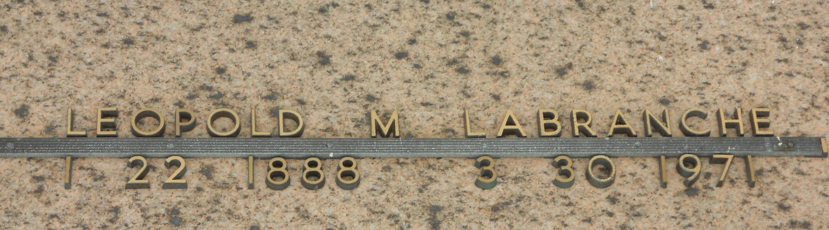
Photo by Team T-Lo

Age 83 years, a native of Montz, Louisiana, and a resident of Laplace, Louisiana.

Husband of the late Amelie Perilloux. Father of Mrs. Alfred Schexnayder, Mrs. Frank Vicknair Jr, Mrs. Elmore (Ella) Madere and Joseph and Earl LaBranche, all of Laplace, Mrs. Remie Granier of New Orleans, Paul LaBranche of Montz and the late Henry LaBranche. Brother of Mrs. Marie Guedry of New Orleans.

Services were Thursday 1 Apr 1971 at St Joan of Arc Church with interment in St Peter Cemetery, Reserve, Louisiana.
The Times-Picayune, New Orleans, Louisiana
31 Mar 1971

