Loraine (Duhe) LaBranche
September 5, 1926 – October 19, 2006

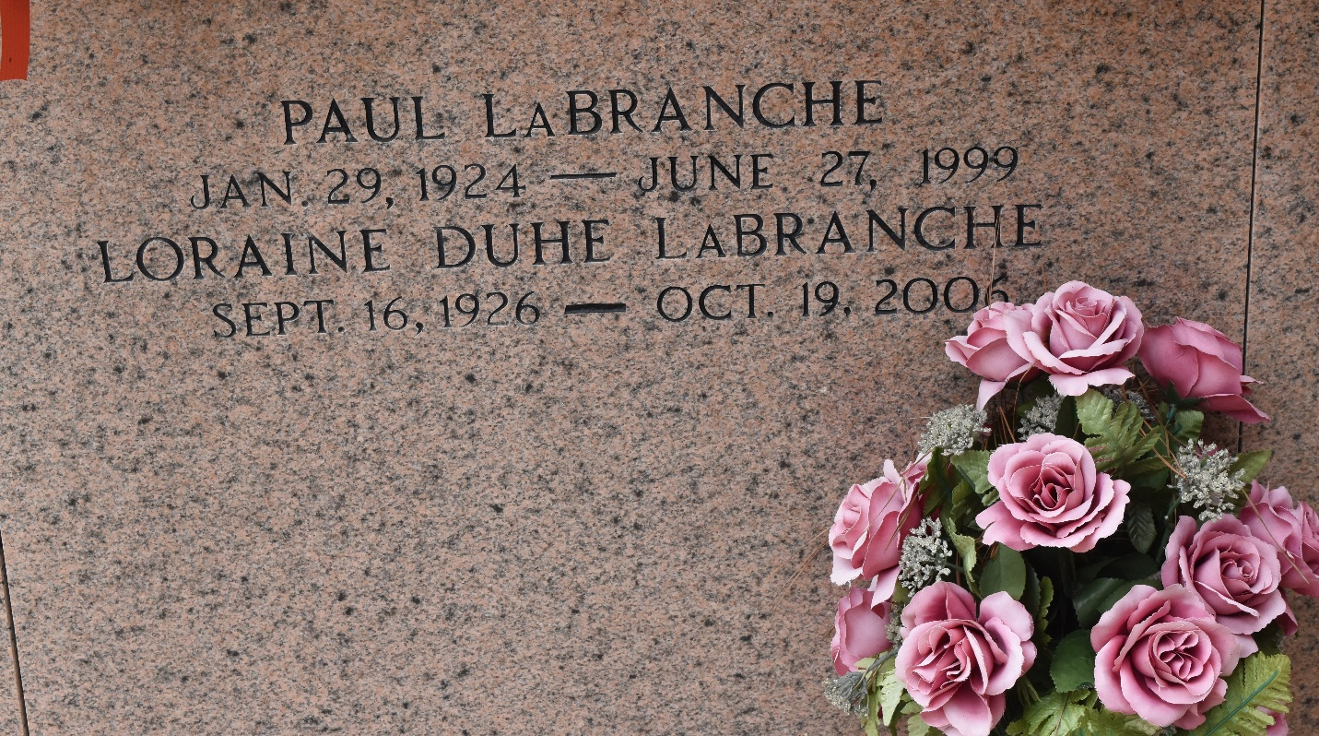

Loraine Duhe LaBranche on Thursday, October 19, 2006 in Jefferson, LA. Wife of the late Paul LaBranche. Daughter of the late Louis Sidney and Leoda Simon Duhe. Mother of Larry LaBranche and wife, Phyllis LaBranche and Joey LaBranche and wife, Marsha LaBranche. Sister of Dorothy LaBranche, Yvonne Richoux, Catherine Weber, Alton Duhe and Lloyd Duhe. Grandmother of Corey, Nicole and April LaBranche and Holly Troxler. Great-
grandmother of Bryce and Tristen Troxler. Age 80. A native of Montz, LA and a resident of Destrehan, LA.
Times Picayune, New Orleans, Louisiana
October 22, 2006

