Murphy Joseph LaBranche Sr.
September 8, 1925 – March 31, 2009

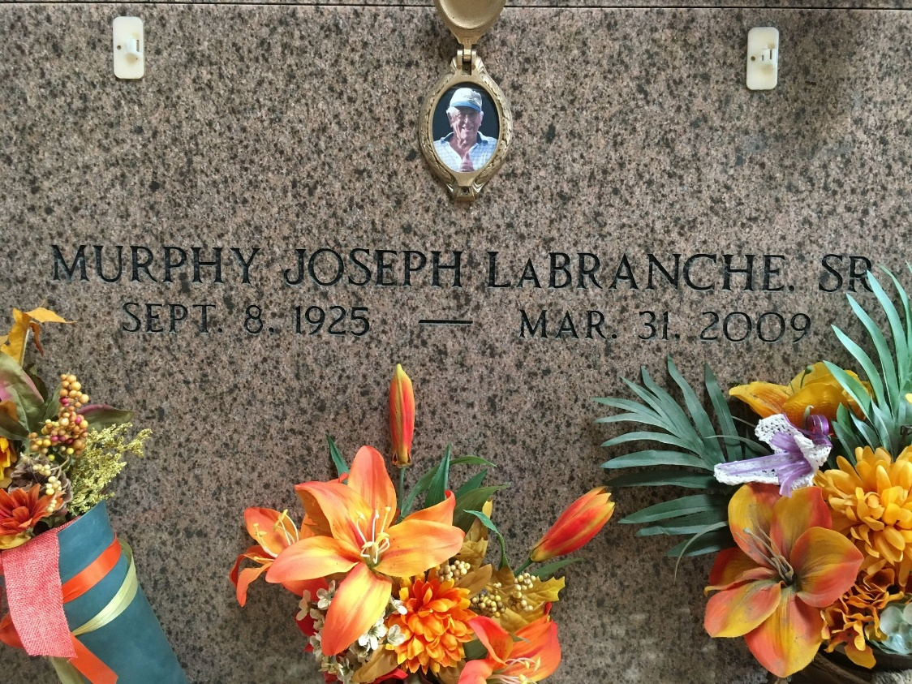
Photo by Team T-Lo

Murphy J. (Liz) LaBranche, Sr. on Tuesday, March 31, 2009 at 11:05am. Beloved husband of Dorothy Duhe LaBranche. Father of Diana Marse and husband Kevin, Joanne Weber and husband Nolan (Pecka) and Murphy (Jay) LaBranche, Jr. and wife Robin. Grandfather of Jessie and Chad LaBranche, Brandy Quin, Jason Marse, Brandon and Matthew Weber. Also survived by 9 great grandchildren. Son of the late Louis, Sr. and Zulma LaBranche. Brother of Myrtle Laiche, Mildred Grisoli and the late Roland and Louis LaBranche, Jr., Dorothy Vicknair and Ethel Landeche. Age 83 years. A native of LaPlace, La and a resident of Montz. Relatives and friends, also Shell Chemical employees, are invited to attend services. Visitation at Millet-Guidry Funeral Home, 2806 W. Airline Hwy., LaPlace, La., on Thursday, April 2, 2009 from 9:00am to 10:45am. Followed by Religious Services at St. Joan of Arc Catholic Church, LaPlace at 11:00am. Burial in St. Peter Cemetery, LaPlace, La.
The Times-Picayune, New Orleans, Louisiana
Apr. 1, 2009

