Paul J. LaBranche
January 29, 1924 – June 27, 1999

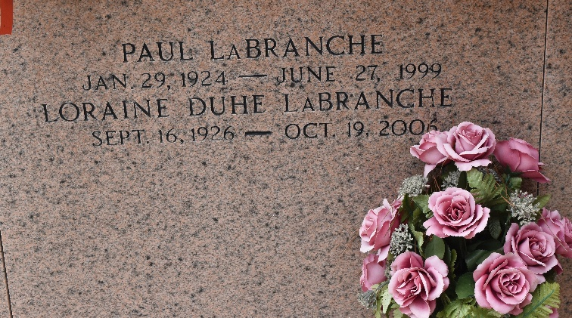

Died Sunday 27 Jun 1999, a native and resident of Montz, Louisiana. Husband of Loraine D LaBranche and father of Larry and Joey LaBranche. Son of the late Leopole and Amelia LaBranche and brother of Joseph LaBranche, Ella L Foret, Mae L Granier and the late Henry and Earl LaBranche, Pauline L Vicknair, Melina L Schexnayder and Earline LaBranche. Services were Tuesday 29 Jun 1999 at Sacred Heart of Jesus Catholic Church, Norco, Louisiana, with interment in St Peter Cemetery, Reserve, Louisiana.
The Times-Picayune, New Orleans, Louisiana
June 28, 1999
**

Paul LaBranche, a native and resident of Montz, died June 27. He was the husband of Loraine D. LaBranche and father of Larry and Joey LaBranche. He was also the son of the late Leopold and Amelie LaBranche and brother of Ella Foret, Mae Granier, Joseph LaBranche and the late Pauline Vicknair, Melina Schexnayder and Earline, Henry and Earl LaBranche. He is also survived by four grandchildren. Services were held June 29 at Sacred Heart of Jesus Catholic Church, Norco, with interment at St. Peter Catholic Cemetery, Reserve.
L'Observateur, LaPlace, Louisiana
June 30, 1999

