Harold J. LaFountain
December 26, 1941 – November 4, 2012

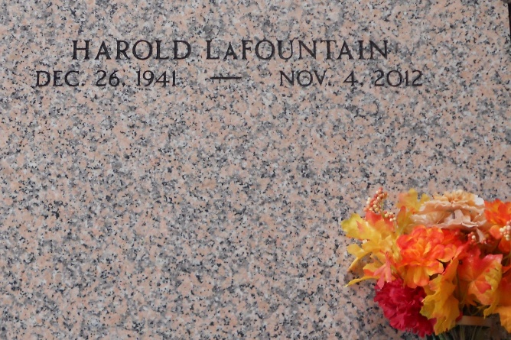
Photo by Team T-Lo

Harold J. (Chief) LaFountain passed away on Sunday November 3, 2012.
Beloved husband of Judy Oubre LaFountain. Father of Paul LaFountain, Jeff LaFountain (Eve), Harold LaFountain Jr., (Kambra) and Missy Bourgeois. Also survived by 11 grandchildren. Son of the late Maxium and Sarah LaFountain. Brother of Judy Hudy, Betty Fredrick, Dorothy Freeberg and the late Marie Engles, Dora Weinert, James, Fritz and Max LaFountain. Age 70. A native of North Dakota and resident of Reserve, LA.
Relatives and friends are invited to attend services. Visitation at St. Peter Catholic Church, Reserve, LA on Thursday November 8, 2012 from 8:00 am to 10:00 am followed by Mass at 10:00 am. Burial in St. Peter Cemetery, Reserve, LA.
The Times-Picayune, New Orleans, Louisiana
Nov. 5 to Nov. 7, 2012

