Hilda (Vicknair) Labat
October 19, 1918 – June 20, 1999

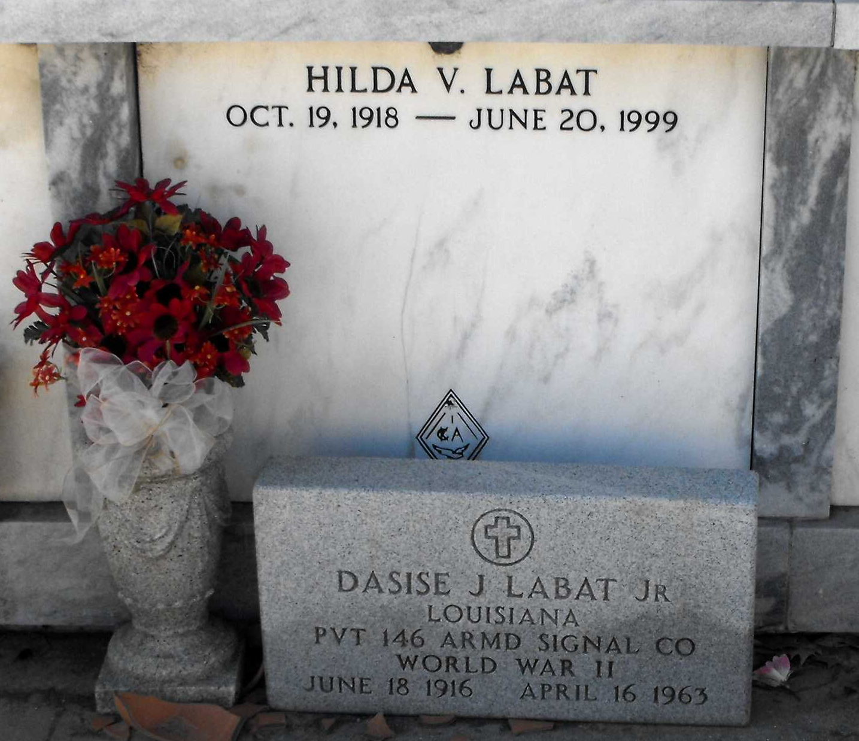
Photo by Mary Agnes Hammett

Hilda V. Labat, 80, a native and resident of Reserve, died June 20. She was the wife of the late Dasise Labat Jr. and mother of Debra and J.D. Labat. She was also the sister of Thelma Bourg, Beatrice Lasseigne, Edna Mae Montzand, the late Francis Vicknair. Services are today at 10 a.m. at St. Peter Catholic Church, Reserve, with interment at the church cemetery. Visitation starts at 8 a.m.
L'Observateur, LaPlace, Louisiana
June 23, 1999

