James Ray Labat Sr.
December 1, 1935 – August 30, 2021

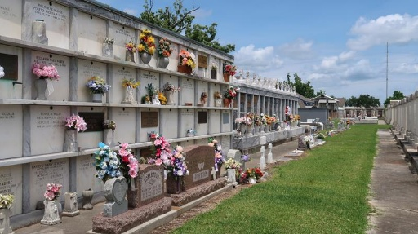

James "Jimmy" Ray Labat, Sr. passed away on Monday, August 30, 2021 at home with his family around him at the age of 85. He was born in New Orleans, but was a resident of LaPlace (St. John the Baptist Parish) for at least 60 years.
He is preceded in death by his parents, Noelie M. Vicknair Labat and Edward P. Labat; 2 sisters, Jerry Ann Labat Lococo and Elaine Labat Dubroc; and 2 sons James "Whitey"/"Jimmy" R. Labat Jr. and Richard "Rickey" "Perch" J. Labat.
Jimmy is survived by his wife of 66 years, Margaret Dorothy Meyer Labat; 4 children, Rodney D. Labat, Leilani A. (David) Crane, Lisa A. (Allen Jr.) Fabre, and Jane L. (Norbert) Weinert; 11 grandchildren, April Labat, Amber Labat, Melissa (Hogan) Norvet, Autumn Fabre, Allen "AJ" (Lacie) Fabre III, Adam (Anna) Fabre, Morgan Fabre (Hunter), Norbert (Maya) Weinert Jr., Nicholas Weinert, Nathaniel (Nichole) Weinert, and Natalie Weinert; and 7 great grandchildren, Reanna Coleman, Mia Coleman, Faith Reid, Caleb Fabre, Merryn Fabre, Olive Norvet, Naxten Weinert and with #8 little boy Fabre on the way. Also survived by his in-laws, nieces, nephews, cousins, and half brother, Benny Labat.
Jimmy served in the U.S. Army, was self-employed as a House Painter and a Nuisance Alligator Trapper for St. John The Baptist Parish. He also loved his Fur Trapping, Hunting, and Fishing. He was a Cube Scott Leader, Baseball Coach, and Umpire for his kids at Larayo Recreation Center in LaPlace.
He is now at peace with his Mom, 2 Sisters, and 2 Sons who he so Deeply Missed. He was always the happiest around his kids, grand and great grand-children. He will be Greatly Missed and Loved by his Family.
Relatives and friends are invited to attend the Visitation and Memorial Mass at St. Joan of Arc Catholic Church, 529 W. 5th St., LaPlace on Saturday, October 16, 2021. Visitation at the church from 9:15 a.m. to 10:00 a.m. followed by a Memorial Mass at 10:00 a.m. Inurnment in St. Peter Cemetery in Reserve. Arrangements by Millet-Guidry Funeral Home.

The Times-Picayune, New Orleans, Louisiana
Oct. 4 to Oct. 16, 2021

