Leroy J. Labat
July 30, 1930 – January 16, 2014

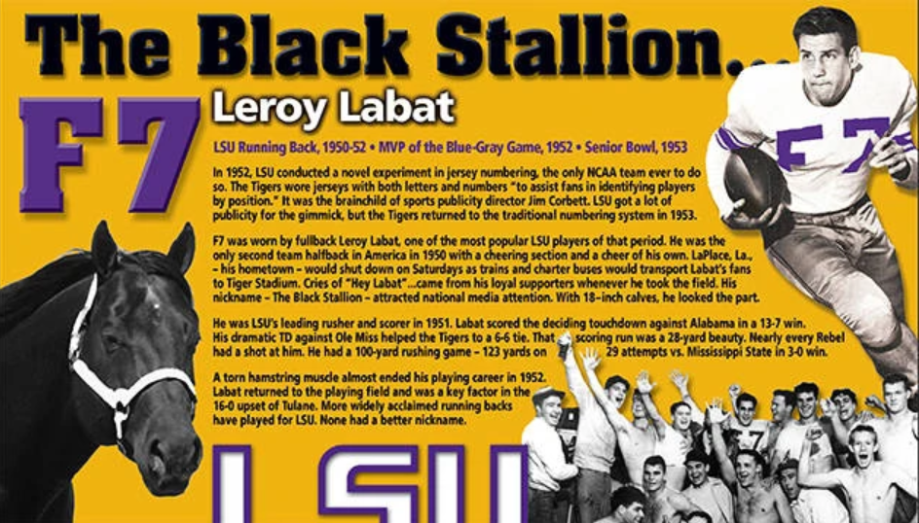

A native of LaPlace, La., Labat was a two-year letterwinner at halfback for LSU in 1951 and 1952, when he was named a team captain. Labat, who was nicknamed “The Black Stallion”, led LSU in both rushing (574 yards) and scoring (30 points) in 1951, helping the Tigers to a 7-3-1 overall mark under head coach Gaynell Tinsley.
Labat scored the deciding touchdown in a 13-7 win over ninth-ranked Alabama in 1951 and he scored LSU’s only TD on a 28-yard run in a 6-6 tie against Ole Miss. He also set what was then a school record, rushing 29 times for 123 yards in a 3-0 victory over Mississippi State.
A torn hamstring muscle almost ended his career at LSU as he missed most of his senior season in 1952. Labat recovered in time to play a major role in a 16-0 upset of Tulane in New Orleans in the season-finale.
Following the 1952 season, Labat earned most valuable player honors in the Blue-Gray game and he also played in the Senior Bowl that year.
After his playing days at LSU, he served in the Marine Corps. Labat returned to LaPlace after military service and became a successful businessman where he also served as president of the South Louisiana Port Commission.
Labat was a loyal Tiger football fan and season ticket holder for many years. He attended all LSU home games until the mid-90s. Among his close friends were former LSU athletic directors Jim Corbett and Joe Dean.

Lsusports.net
**

Leroy J. Labat died on Thursday January 16, 2014. Beloved husband of the late Janice Dufresne Labat. Father of Leslie L. Foret, Kerry and Layne Labat. Also 8 grandchildren and 6 great-grandchildren. Son of the late Lawrence and Elsie Gautreaux Labat. Brother of Daniel Labat, Thelma Cheek and the late Gerald Labat and Verna McTyre. Age 83. A native and resident of LaPlace, LA. Relatives and friends are invited to attend services. Visitation at Millet-Guidry Funeral Home, 2806 W. Airline Hwy., LaPlace, LA on Monday January 20, 2014 from 5:00pm to 7:00pm, followed by Religious Services in the Funeral Home Chapel at 7:00pm. Burial to be private at a later date.

The Times-Picayune, New Orleans, Louisiana
Jan. 16 to Jan. 19, 2014

