Noelie Marie (Wempren) Labat
February 1, 1877 – October 28, 1959

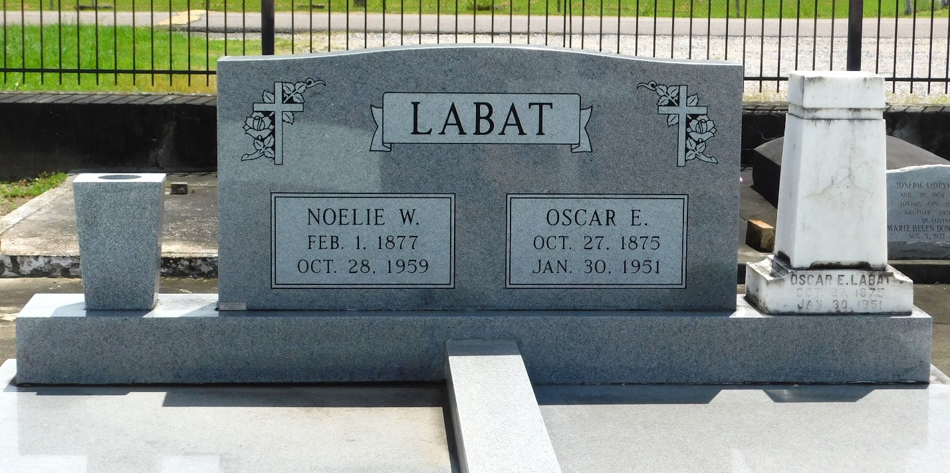
Photo by Mary Agnes Hammett

Noelie Marie Wempren, widow of Oscar Labat, at her residence at Laplace, LA, on Wed 28 Oct 1959 at age 82 years. She was the mother of J.A., Roy and Edward Labat, all of Laplace, John U. Labat of New Orleans, and Lawrence Labat of Houma, LA. Sister of Eve Madere. She was a native and lifelong resident of Laplace. Funeral services were Friday, 30 Oct 1959 with interment in St Peter Cemetery, Reserve, LA.
The Times-Picayune, New Orleans, Louisiana
Friday, 30 Oct 1959, p. 2

