Thomas Joseph Labella Jr.
March 25, 1966 – January 21, 2013

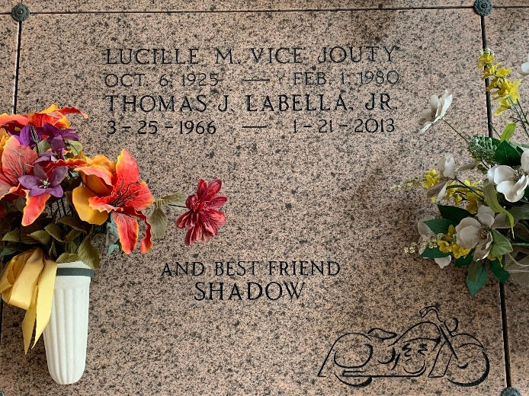
Photo by Team T-Lo

Thomas Joseph LaBella, Jr. was born on March 25,1966 in Lutcher, Louisiana. "Junior" was 46 years old and resided in Kenner. His soul departed this earth as the sun rose on Monday, January 21, 2013 near Destrehan, La.
He is survived by his son, Antonio Joseph LaBella; his sister, Anne LaBella Fox; mother, Gloria Jouty LaBella; his beloved companion, Ms. Rene Roy; and numerous cousins, uncles, aunts, nieces and nephews. He will also be sadly missed by his best friend and pitt bull, Shadow. He was preceded in death by his father, Thomas Joseph LaBella Sr; his paternal grandparents, Joseph LaBella, Sr. and Rita Huxun LaBella; as well as his maternal grandparents, Victor Jouty and Lucille Bice Jouty.
Thomas Joseph LaBella, Jr. served with honor on the Avondale Shipyard Fire and Rescue Brigade as well as the Kenner Volunteer Fire Dept, where he was honored after responding to over 130 emergency calls for fire, EMS and rescue. He will also be remembered for his love of helping friends, motorcycles, weaponry, fishing and the family legacy of gourmet Italian cooking. He was known to his dearest niece and nephew as "Uncle Butterbean."
A memorial visitation will be held at L. A. Muhleisen and Son Funeral Home, 2607 Williams Blvd., Kenner on Monday, January 28, 2013 from 4:00 p.m. until 6:00 p.m. A private interment will be held at a later date. The family has requested that in lieu of flowers that contributions be made to the American Heart Association or Kidney Fund of Louisiana.

The Times-Picayune, New Orleans, Louisiana
Jan. 26 to Jan. 27, 2013

