Paul C. Labiche Sr.
July 18, 1910 – September 13, 2003

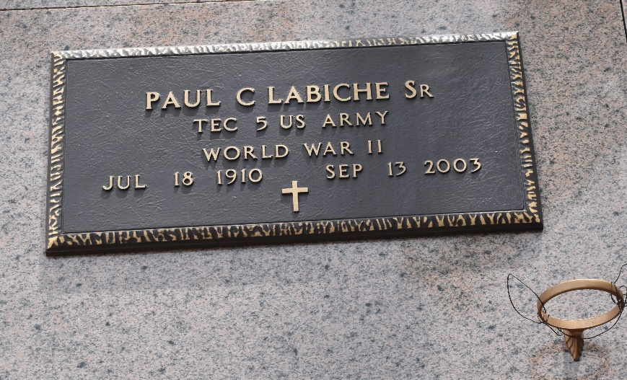
Photo by Mary Agnes Hammett

Paul C. Labiche On Saturday September 13, 2003 At 3:05 A.M. Age 93, A Native Of Garyville And A Resident Of Laplace For The Past 45 Years.
Beloved Husband Of The Late Genevieve Duhe Labiche. Father Of Paul Labiche, Jr. And Jacqueline L. Barberito. Grandfather Of Paul, Iii, Jessica, Joshua And Matthew Labiche And Christopher, Kelly And Corey Barberito.
Son Of The Late Sidney And Virginia Ory Labiche. Brother Of The Late Florence And Louis Labiche.
Relatives And Friends Of The Family Are Invited To Attend Services. Visitation At Millet- Guidry Funeral Home, 2806 W. Airline Hwy., Laplace, La On Monday, September 15th From 8 A.M. To 11 A.M., Followed By Religious Services At St. Joan Of Arc Catholic Church, Laplace At 11 A.M. Burial In St. Peter Cemetery, Reserve, La.

Times Picayune, New Orleans, Louisiana
September 14, 2003

