Amelie (Perilloux) LaBranche
April 11, 1891 – March 11, 1960

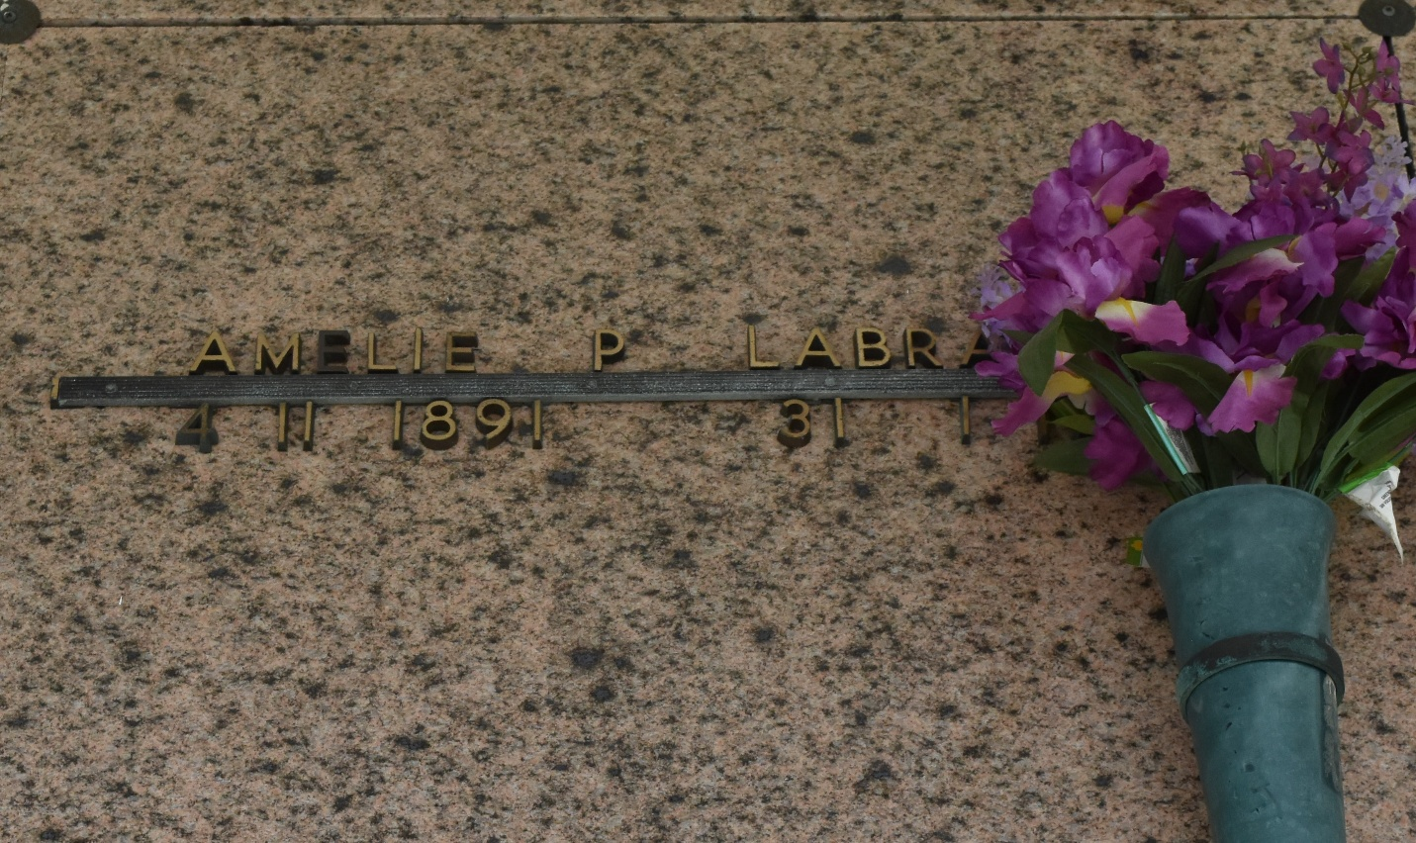

Died in Laplace, Louisiana, on Friday 11 Mar 1960 in her 69th year, a native and resident of Laplace. Wife of Leopold La Branche and mother of Mrs. Alfred Schexnayder, Mrs. Frank Vicknair Jr, Mrs. Elmore Madere and Earl, Joseph and Paul La Branche, all of Laplace, and Mrs. Remie Granier of New Orleans and the late Henry La Branche. Services were Saturday 12 Mar 1960 at St Joan of Arc Church, Laplace, with interment in St Peter Cemetery, Reserve, Louisiana.
The Times-Picayune, New Orleans, Louisiana
12 Mar 1960

