Tommy Dean Lacarbo Sr.
August 8, 1957 - June 23, 2023

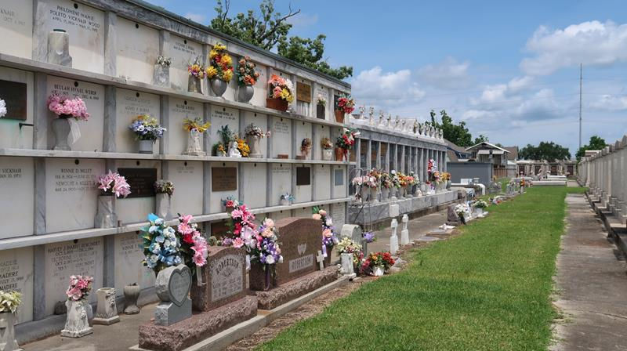

Tommy Dean Lacarbo, Sr. (The Tin Man), Garyville, passed away on June 23, 2023, at the age of 65. He is preceded in death by his parents, Peter and Beatrice Lacarbo.
He is survived by his beloved wife, Loretta Vicknair Lacarbo, his children, Tommy Lacarbo, Jr. (Nancy), Chad Lacarbo and Aaron Lacarbo (Laura), his grandchildren, Xavian, Brianna, Madyson, Peyton, Paisley, Ryder, Sayler, Cooper and his siblings, Peter, Alvin, Barry, Anthony Lacarbo, Agnes Harvey, Susan Millet, Wanda Decoteau and the late Roy Deslatte.
Relatives and friends are invited to attend a Funeral Mass at 11:00 AM on Wednesday, June 28, 2023, at St. Hubert Catholic Church, 176 Anthony F. Monica Street, Garyville, LA 70051. Visitation will begin at 9:00 AM. Interment will be in St. Peter Catholic Cemetery in Reserve, LA.
Millet-Guidry Funeral Home, LaPlace, Louisiana
June 24, 2023

