James Edward Ladner
February 5, 1947 – September 29, 2020

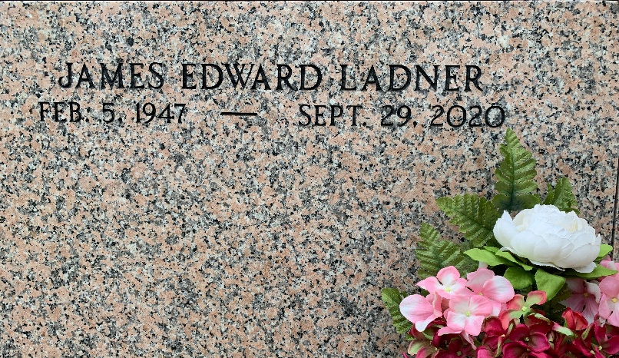
Photo by Team T-Lo

James Edward Ladner passed away on Tuesday, September 29, 2020. Age 73, a native of Necaise Crossing, MS and a resident of Reserve, LA.

Beloved husband of Linda Maurin Ladner. Father of Bertha (Beth) Kahl (Charlie), Amanda Richardson (David), and Toni Ladner. Grandfather of David (D.J.) Richardson and Mason Vicknair. Son of the late Edward James (Fred) and Alezia Necaise Ladner. Brother of JoAnn Moran (Andy).

Relatives and friends are invited to attend the visitation at Millet-Guidry Funeral Home, 2806 W. Airline Hwy, LaPlace, LA on Saturday, October 3, 2020 from 9:00 a.m. to 11:00 a.m. followed by the Graveside Service and burial in St Peter’s Cemetery, Reserve, LA. To share memories or condolences, please visit www.milletguidry.com
L’Observateur, LaPlace, Louisiana
October 1, 2020

