Lawrence J. Laiche Jr.
April 27, 1956 – April 19, 2022

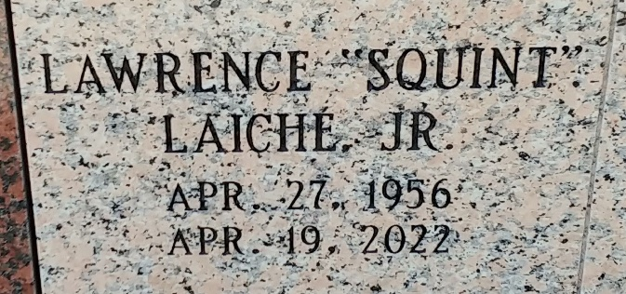
Photo by Team T-Lo

Lawrence J. Laiche Jr, 65 was called home on April 19, 2022 surrounded by family and friends.
He was the dedicated husband of Penny Clement Laiche for 12 years and loving step dad of Jennifer Ortiz Dugas (Trey), Toby Duhe, (Angie), Danielle Duhe Tyrrell (Eric), and Joel Ortiz (Amanda). He is also survived by step grandson Landyn, and step granddaughters Lainnie, Lauren, Sarah, Kaitlyn, Abby, Grace, McKenzie, and Sophia, Sisters Fay Audiffred, Lynne Acosta, sisters in law Margaret Laiche, and Cheryl Entremont; brothers in law Ernie Clement (Karen), Darryl Clement (Noel), and Davey Clement (Dawn).
Also survived by many nieces, nephews and his fur baby Hounddog.
He is preceded in death by his parents Lawrence J and Altheanne Borne Laiche Jr., brother Edwin Laiche and brothers in law Sidney Audiffred, Ronald Acosta and Greg Entremont, nephews Raymond Laiche, Bret Acosta, Kyle Acosta and his best friend Billy Borne.
Relatives and friends are invited to attend visitation on Wednesday April 27, 2022 at St. Hubert Catholic Church, 541 S Church Street, Garyville, Louisiana from 9:00 a.m. until Mass of Christian Burial at 11:00 a.m. Burial at St Peters Catholic Church Cemetery in Reserve, LA. Bereavement at St Huberts Church Hall, Garyville. In lieu of flowers, masses preferred.
The family would like to thank No Place Like Home Caregivers Services LLC (Suzanne, Bonnie, and Gail) and caregivers Lyntrell and Donna for their compassion and kindness and Compassus Hospice.

The Neptune Society

