Josefina Lainez
September 8, 1918 – September 26, 2008

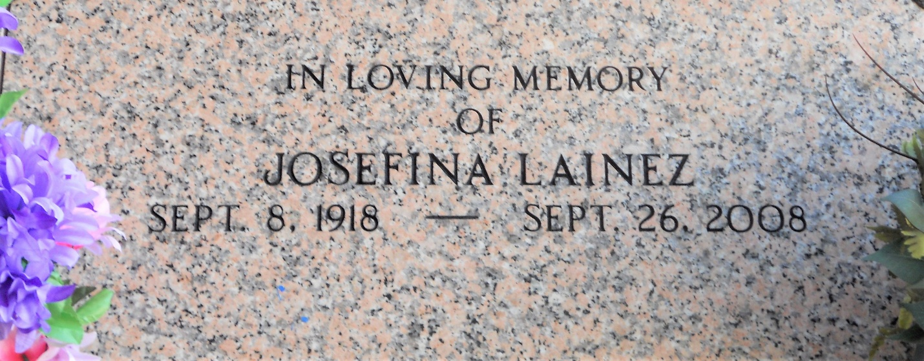
Photo by Team T-Lo

Josefina Lainez on Friday, September 26, 2008.
Beloved wife of Tiburcio Lainez. Mother of Vilma Gay, Augusto Chicas, Leonel Chicas, Hugo Chicas, Carlos Lainez, Martha Guzman and Wilfredo Lainez. Grandmother of Ondina Trigueros, Geraldina and Ivette Kunkel, and 18 other grandchildren. Great-grandmother of Jennifer Trigueros, Savannah Maus, Dylan Pete and 11 other great-grandchildren. Age 90 years. A native of Honduras and a resident of LaPlace, La. for the past 25 years.
Times-Picayune, New Orleans, Louisiana
September 30, 2008

