Bernadette (Vicknair) Lambert
June 25, 1953 – March 28, 2014

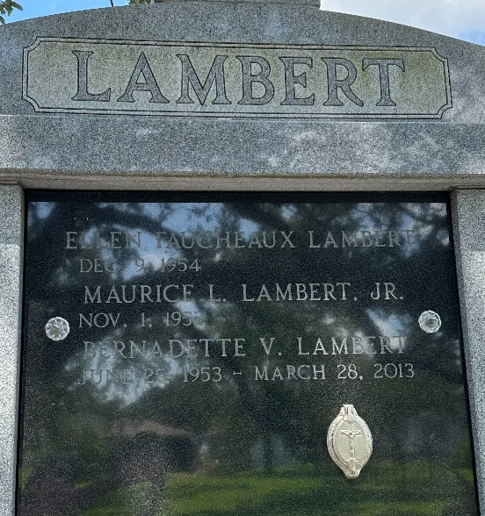
Photo by Team T-Lo

Bernadette Vicknair Lambert, beloved wife, mother, sister, daughter and friend, passed away quietly at her home while surrounded by her family on March 28, 2013 at the age of 59, after a brief battle with cancer.
Bernadette, a native of Paulina, became a resident of Reserve in 1972 after meeting the love of her life and loving husband of 40 years, Maurice Lambert, Jr. Bernadette leaves behind many memories to be cherished by her husband Moe; three daughters: Kim Herrmann and husband Frank; Sadie Mayo and husband Tabor; Ashley Bossier and fiancé Allen Vicknair; one son Cody Lambert; six grandchildren: Klein and Keira Herrmann; Brice and Londyn Mayo; Amy and Cameron Bossier; as well as four sisters: Darleen Maus and husband Pat; Justine Hymel and husband Moise, Aimee St. Pierre, Dora Amato and husband Craig; two brothers, Terry "Toe" Vicknair, Paul Vicknair, and mother Audrey Roussel Vicknair. She is also survived by many nieces and nephews.
Bernadette is preceded in death by her father, Paul "Pill" Vicknair, and mother-in-law and father-in-law, Denise and Maurice Lambert, Sr.
Bernadette's favorite activities included spending time at home with her family, watching her grandchildren's games at the ballpark, and going to the casino with her sisters and friends. Her smile, compassion, and love of life will be missed dearly.
Visitation will be held at Rose Lynn Funeral Services, 1870 Cabanose Ave., Lutcher, LA on, from 6:00 p.m. until 9:00 p.m. on Monday, April 1, 2013. Visitation will resume at the funeral home on Tuesday, April 2, 2013 from 8:30 a.m. until 10:30 a.m. followed by a Mass of Christian Burial at St. Peter Catholic Church in Reserve, LA. Burial will follow in the church mausoleum. ROSE LYNN FUNERAL SERVICES is in charge of the arrangements.

The Advocate, Baton Rouge, Louisiana
March 29 – April 2, 2013

