Claire Bernadette (Barbier) Lambert
September 3, 1880 – December 12, 1962

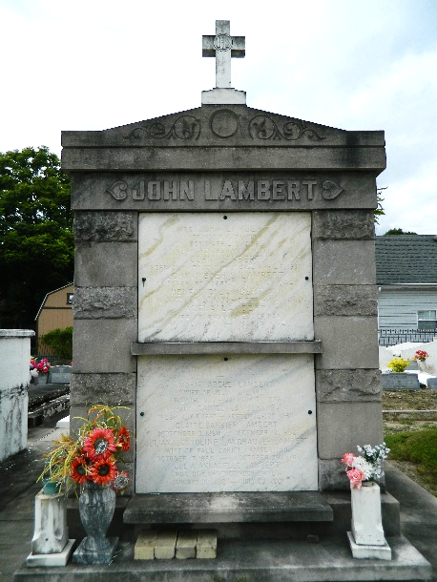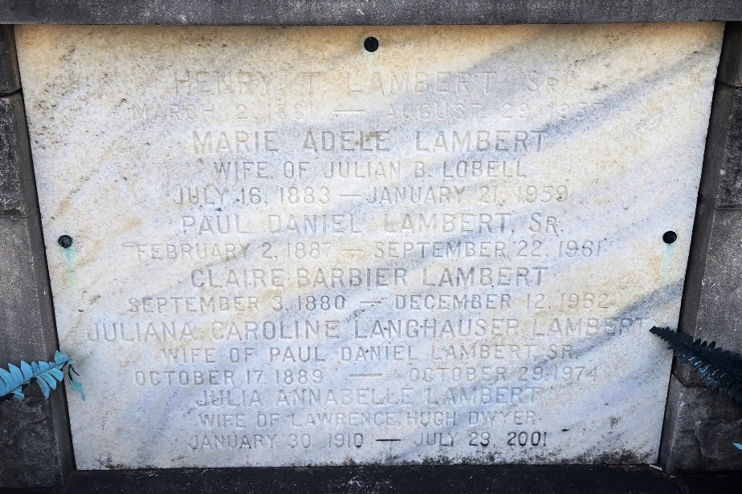

Age 82 years, a native of Assumption Parish, Louisiana, and a resident of St Rose, Louisiana, for the past 60 years. Wife of the late Henry T Lambert, mother of Mrs. Horace Waguespack of St Rose and the late Henry T Lambert Jr. Daughter of the late Leonelie Le Blanc and Augustin Barbier, sister of Mrs. A Barbier of Gretna, Louisiana, and the late Mrs. Poliska Lambert, Cordelia Landry, Ernestine Rongullo, Margaret Belle, Aluina Becknel, Ulysses, Ernest and Edward Barbier.

Services were Thursday 13 Dec 1962 at St Charles Borromeo Church, Destrehan, Louisiana, with interment in St Peter Cemetery, Reserve, Louisiana.
The Times-Picayune, New Orleans, Louisiana
13 Dec 1962

