Emilie (Montz) Lambert
October 18, 1881 – November 22, 1941

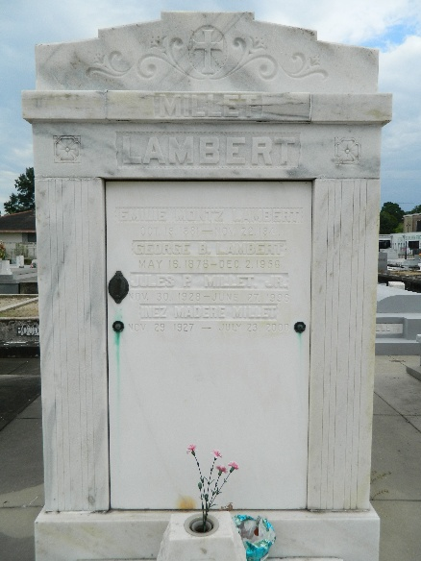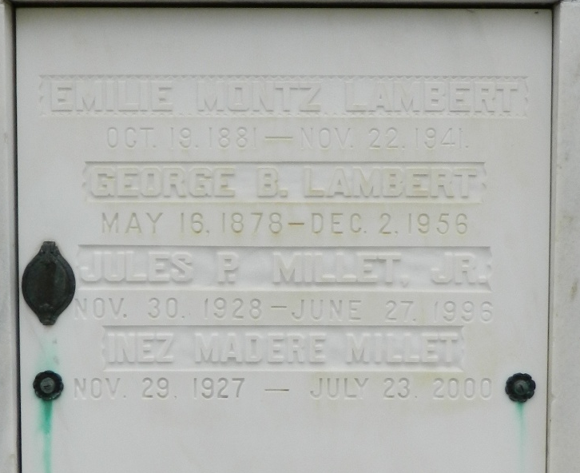

Emilie Montz of St Rose, Louisiana, wife of George Lambert, died on Saturday, 22 Nov 1941 at 11:15 pm at age 60 years.

She was the mother of George B Lambert Jr and was the sister of Mrs. Elias Madere, Blanche, Sister Mary Genevieve, William, George and Armond Montz.

Services were Sunday afternoon, 23 Nov 1941 at 4 o'clock at St Peter Church, Reserve, Louisiana, with interment in St Peter Cemetery.
The Times-Picayune, New Orleans, Louisiana
November 24, 1941

