George Bernard Lambert Sr.
May 16, 1878 – December 2, 1956

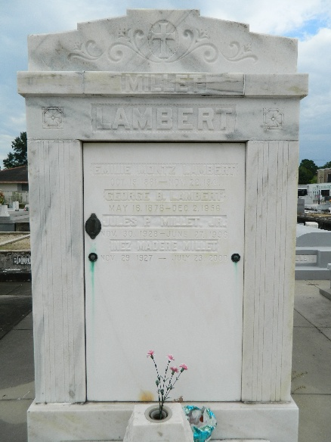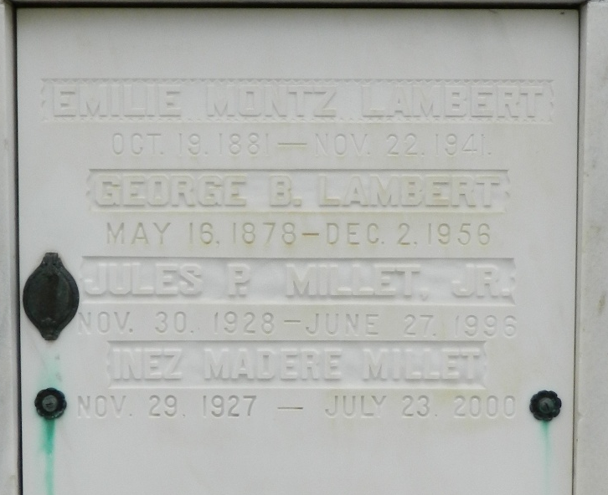

George B Lambert Sr of St Rose, Louisiana, died at Hotel Dieu Hospital, New Orleans, on Sunday, 2 Dec 1956 at 2:25 pm at age 75 years.

He was the husband of the late Emelie Montz and father of George B Lambert Jr. He was the brother of Edmond F, William A, Henry, Tom and Daniel Lambert and Mrs. J B Lobell.

Services were Monday 3 Dec 1956 at St Peter Church, Reserve, Louisiana, with interment in St Peter Cemetery
The Times-Picayune, New Orleans, Louisiana
December 3, 1956

