Henry Thomas Lambert Jr.
October 20, 1909 – April 4, 1950

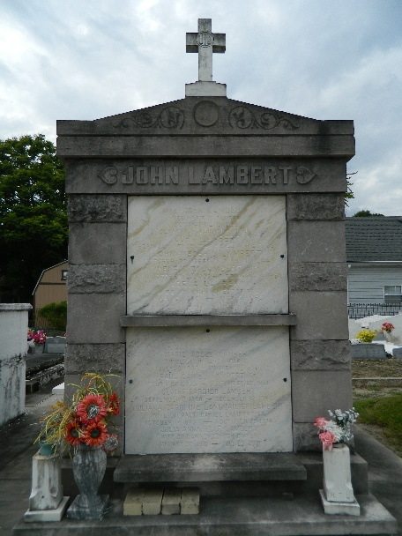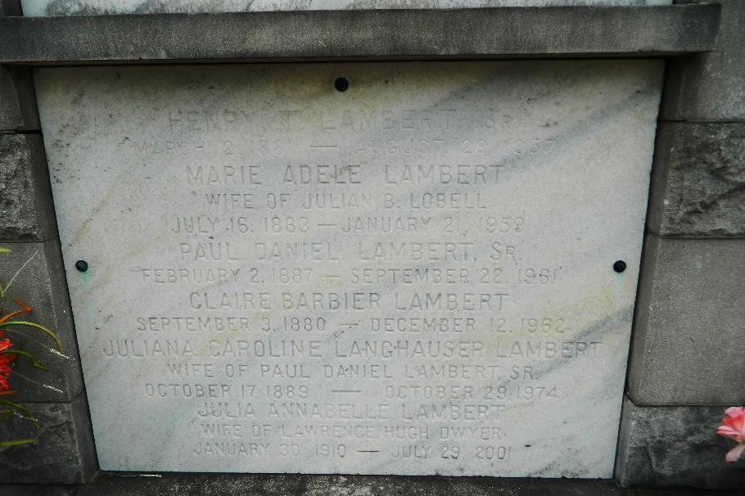

Died Tuesday 4 Apr 1950 at 6 o'clock am.

Son of Henry T Lambert Sr and Claire Barbier. Brother of Mrs. Horace Waguespack.

Services were Wednesday, 5 Apr 1950 at St Charles Borromeo Church, Destrehan, Louisiana, with interment in St Peter Cemetery, Reserve, Louisiana.
The Times-Picayune, New Orleans, Louisiana
December 3, 1956

