Henry Thomas Lambert Sr.
March 7, 1881 – August 29, 1957

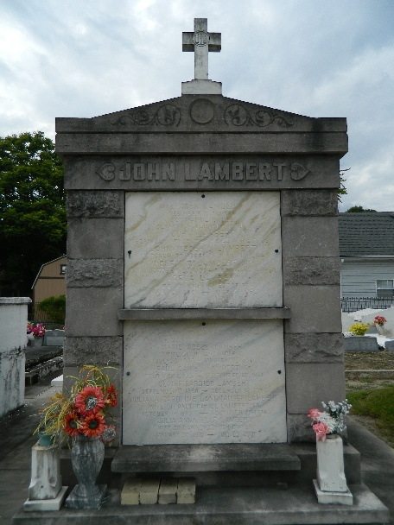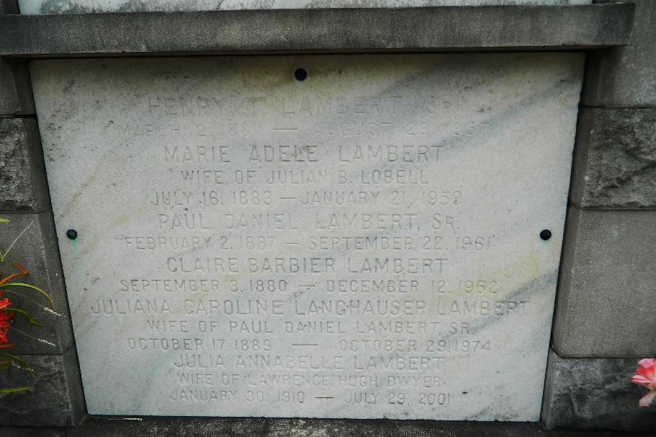

Age 76 years, a native of Livingston Parish, Louisiana, and a resident of St Rose, Louisiana, for the past 65 years.

Husband of Claire Barbier, father of Mrs. Horace Waguespack and the late Henry T Lambert Jr. Brother of Mrs. J B Lobell Sr, P D Lambert, Edmond Lambert, J O Lambert, George B Lambert, W A Lambert and Mrs. Adela Estopinal.

Services were Saturday 31 Aug 1957 at St Charles Borromeo Church, Destrehan, Louisiana, with interment in St Peter Cemetery, Reserve, Louisiana.
The Times-Picayune, New Orleans, Louisiana
August 31, 1957

