John Mederic Lambert
October 20, 1866 – June 18, 1944

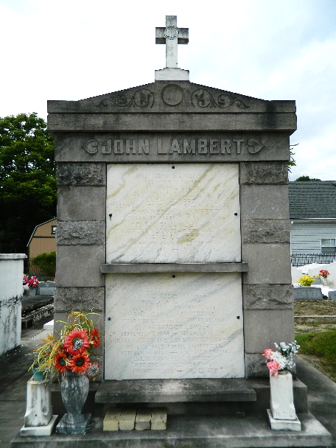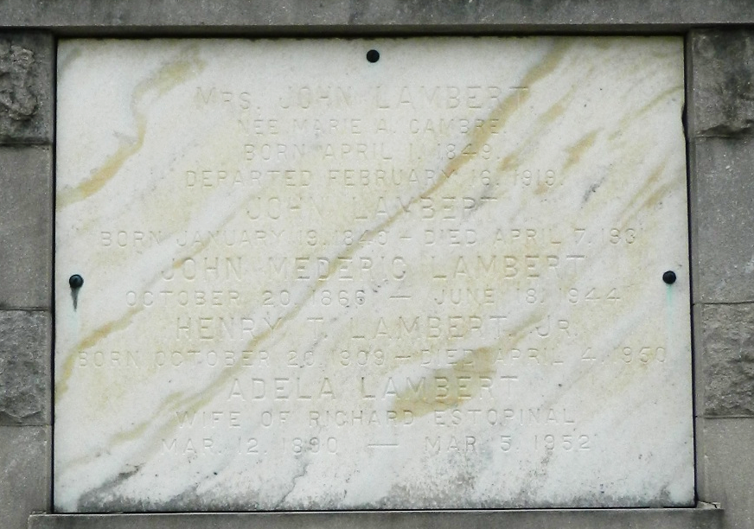

Age 77 years, a native of Reserve, Louisiana, and a resident of St Rose, Louisiana.

Brother of Edmond F, William A, George B, Thomas B and P D Lambert, and Mrs. J B Lobell, Mrs. Richard Estopinal and the late Joseph O Lambert.

Services were Monday 20 Jun 1944 at St Charles Borromeo Church, Destrehan, Louisiana, with interment in St Peter Cemetery, Reserve.
The Times-Picayune, New Orleans, Louisiana
June 20, 1944

