John Symphorien Lambert
January 19, 1840 – April 7, 1931

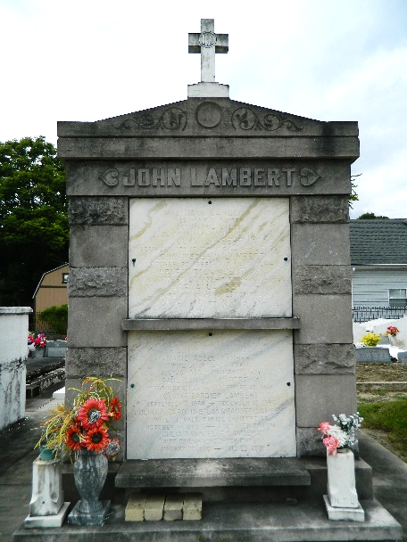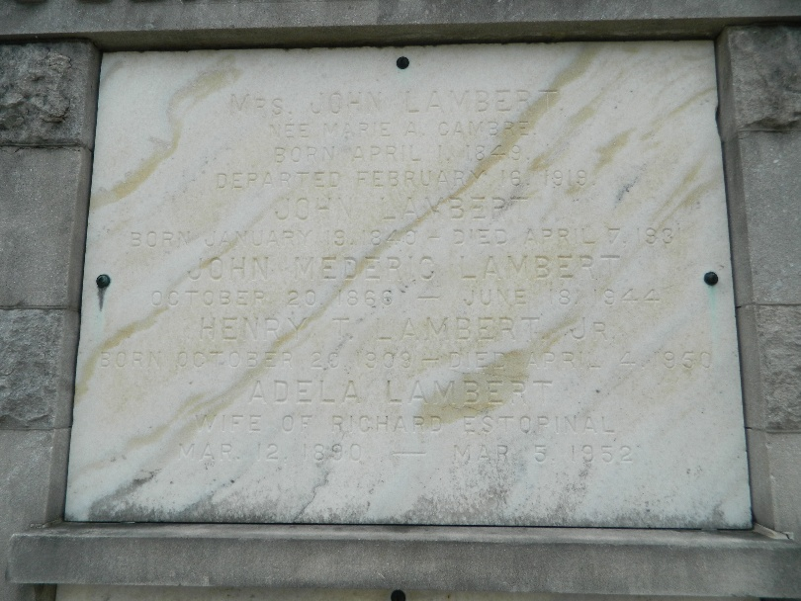

Age 91 years, died at St Rose, Louisiana, husband of the late Marie Cambre.

Father of Mrs. J B Lobell, Miss Adela Lambert, J M Lambert, J O Lambert, E F Lambert, W A Lambert, G B Lambert, H T Lambert, and P D Lambert. Brother of Paul Lambert.

Services were Wednesday, 8 Apr 1931 at St Charles Church, Destrehan, Louisiana, with interment in St Peter Cemetery, Reserve, Louisiana.
The Times-Picayune, New Orleans, Louisiana
June 20, 1944

