Joseph Oliver Lambert Sr.
May 5, 1871 – December 31, 1940

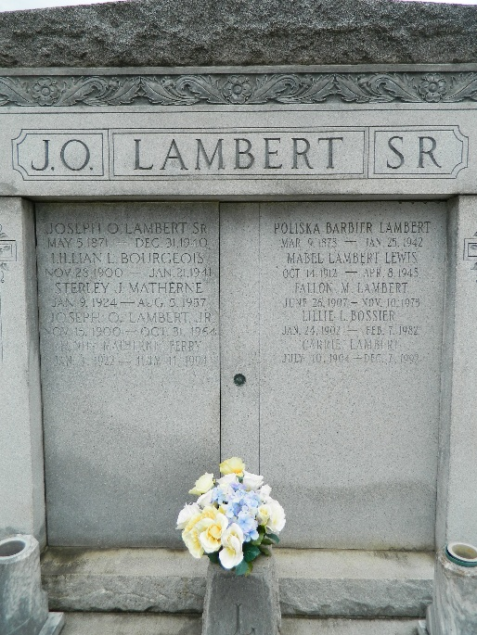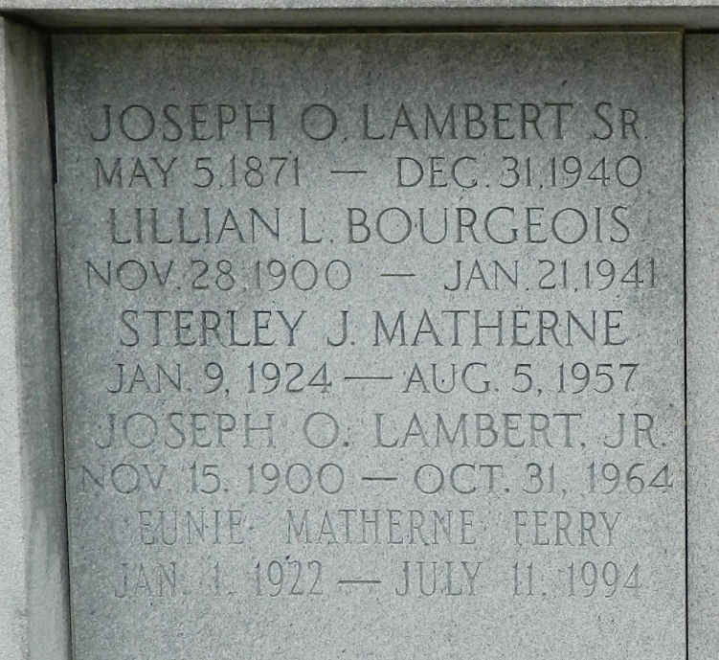

Age 69 years, a native of Livingston Parish, Louisiana, and a resident of St Rose, Louisiana, for the past 40 years.
Husband of Poliska Barbier, father of Joseph Jr, Sidney, Fallon, Evan, Carrie, Mabel and Virgie Lambert, Mrs. Frank Bourgeois, Mrs. Lillie Layne, Mrs. Thomas Saizan and Mrs. Daniel Montz. He was the brother of Mederick, Edmond, George, William, Thomas, Daniel and Adela Lambert and Mrs. J B Lobell.
Services were Thursday 2 Jan 1941 at St Charles Boromeo Church, Destrehan, Louisiana, with interment in St Peter Cemetery, Reserve, Louisiana.

The Times-Picayune, New Orleans, Louisiana
June 20, 1944

