Maurice Louis Lambert Sr.
April 4, 1924 – April 30, 2006

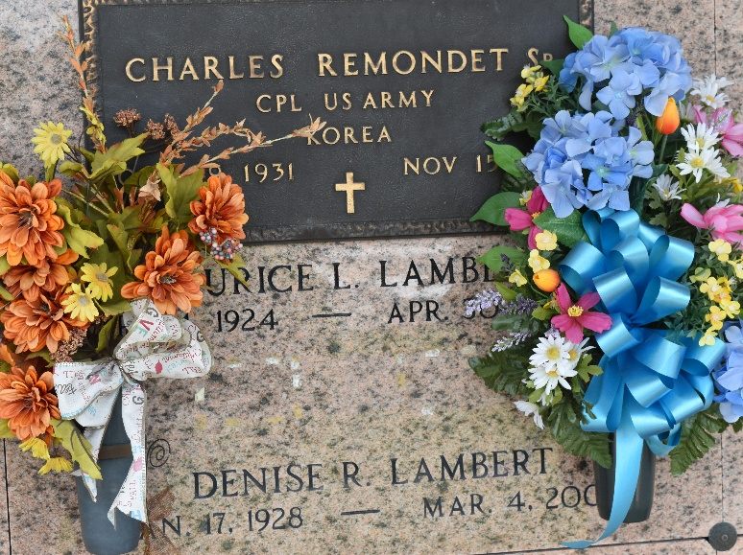

Maurice L. Lambert, on Sunday, April 30, 2006, at 5:00 P.M. Beloved husband of Denise Remondet Lambert. Father of Maurice Lambert, Jr., Betty Webre, Linda McCarty, and Phillis Boyd. Son of the late Edward and Uranie Lambert. Brother of Edward Lambert, Jr., Rose Melancon, and the late Alvin Lambert, Marie Melancon, and Felonise Louque. Also survived by 11 Grandchildren, and 7 Great-Grandchildren. Age 82. A native of Convent, LA and a resident of Reserve, LA for the past 50 years.

Relatives and Friends of the Family are invited to attend services. Visitation at St. Peter Catholic Church, Reserve, LA on Wednesday, May 3, 2006, from 10:00 A.M. to 11:30 A.M. Followed by Religious Services at the church at 11:30 A.M. Burial in Church Cemetery. Arrangements by MILLET-GUIDRY FUNERAL HOME, Laplace, LA.
The Times-Picayune, New Orleans, Louisiana
May 2, 2006

