Poliska Marie (Barbier) Lambert
March 9, 1878 – January 25, 1942

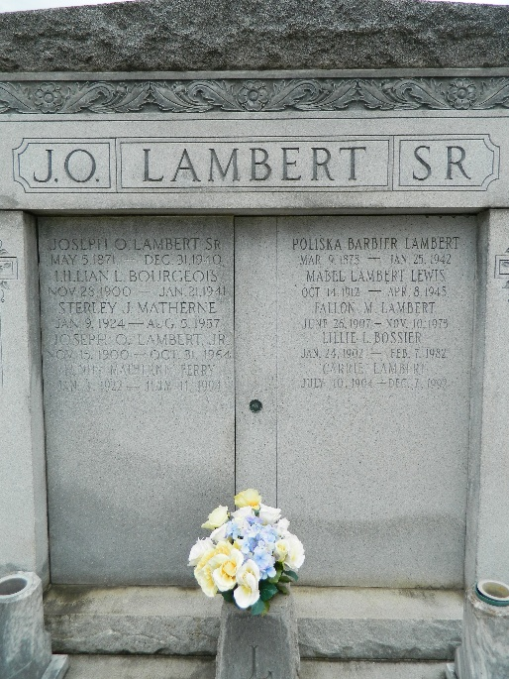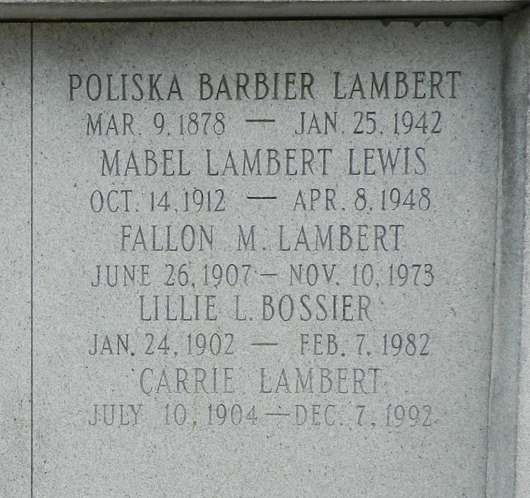

Died at her residence in St Rose, Louisiana, on Sunday 25 Jan 1942, Age 60? years, a native of Assumption Parish, Louisiana, and a resident of St Rose for the past 40 years.

Wife of the late Joseph Oliver Lambert Sr, mother of Joseph Jr, Sidney, Fallon, Evan, Carrie, Mabel and Vergie Lambert, Mrs. Lillie Layne, Mrs. Thomas Saizan, Mrs. Daniel Montz and the late Mrs. Frank Bourgoeis.

Services were Tuesday 27 Jan 1942 at St Charles Borromeo Church Destrehan, Louisiana, with interment in St Peter Cemetery, Reserve, Louisiana.

The Times-Picayune, New Orleans, Louisiana
January 27, 1942

