Alton A. Landry
July 18, 1904 – February 2, 1956

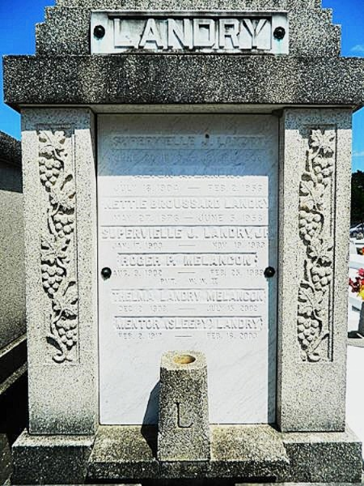

LANDRY - At Laplace, La, on Thursday, February 2, 1956, at 7:45 o'clock p.m., ALTON (BUDDY) LANDRY, beloved son of Nettie Broussard and the late Supervielle Landry, brother of S J Landry of New Orleans, La, Mrs. Julie Payne of Jackson, Miss, Mrs. Edna Rausch of Metairie, La, Mrs. Theresa Brignac of Good Hope, La, and Mrs. Thelma Melancon of Laplace, La, aged 51 years.

Relatives and friends of the family are invited to attend the funeral, which will take place from Millet Funeral Home, Laplace, La, on Saturday, February 4, 1956, at 10:30 o'clock a.m., followed by religious services at St Joan of Arc Church, Laplace, La. Interment in St Peter Cemetery, Reserve, La.

The Times-Picayune, New Orleans, Louisiana
4 Feb 1956, p. 2

