Audrey Mae (Landry) Landry
September 22, 1927 – November 18, 2008

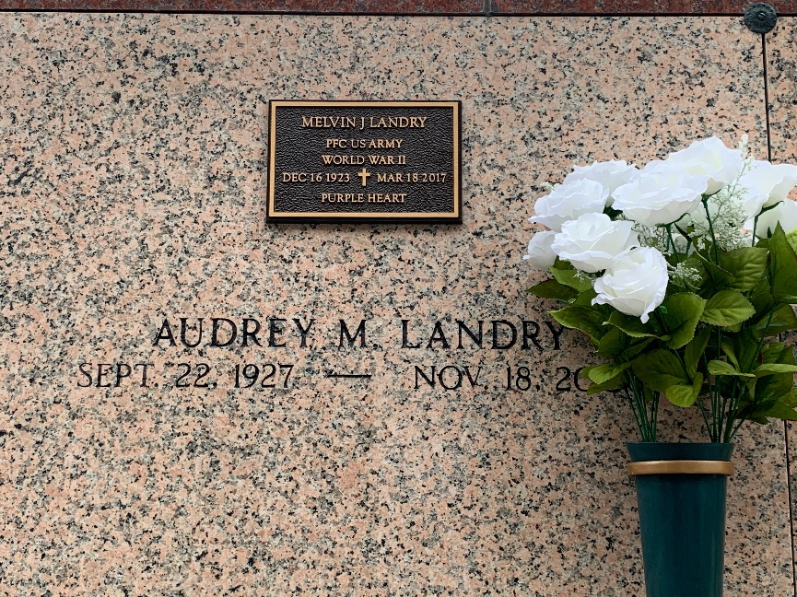
Photo by Team T-Lo

Audrey Mae Landry on Tuesday, November 18, 2008 at 12:45 a.m. Beloved wife of Melvin Landry. Mother of Pamela L. Lemoine and husband Leonard. Grandmother of Sarah Adams and husband Steven. Step-grandmother of Leonard Lemoine Jr. Great-grandmother of Morgan and Brooklyn. Daughter of the late John and Antoinette Landry. Sister of John Jr. and Garland Landry, the late Arthur and Rudolph Landry, Helen Ory, Ethel Badeaux and Clara Melancon.
Special thanks to Hospice of South La. Age 81. A native and resident of Garyville, LA.
Relatives and friends of the family are invited to attend services. Visitation at Millet-Guidry Funeral Home, 2806 W. Airline Hwy. LaPlace, La. on Wednesday, November 19, 2008 from 5:00 p.m. to 9:00 p.m. and on Thursday from 8:00 a.m. to 10:00 a.m. Followed by Religious Services at the Funeral Home Chapel at 10:00 a.m. Burial in St. Peter Cemetery, Reserve, LA.

The Times-Picayune, New Orleans, Louisiana
November 19, 2008

