Averill Luke Landry
September 7, 1934 – August 17, 2013

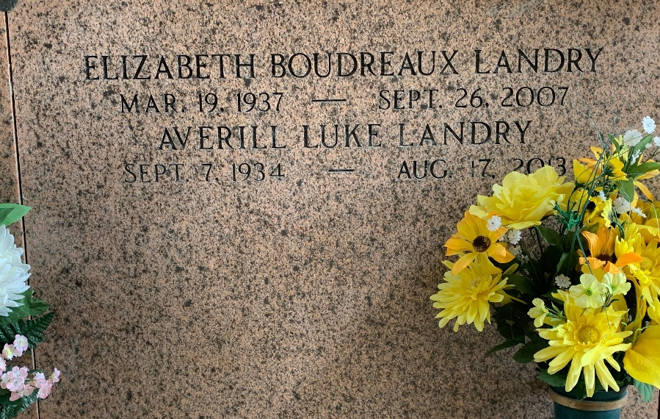
Photo by Team T-Lo

Luke Landry died on Saturday August 17, 2013.
Beloved husband of the late Liz Boudreaux Landry. Father of Alan Landry, Patrice Richard (Terry), Danny and Troy Landry (Loida). Grandfather of Ryan, Justin and Steven Richard, Luke, Danny Jr. and Michele Landry. Great-grandfather of Nathan, Justin, Madison and Cullen Richard and Jayden Louque. Son of the late Kermit and Thelma Landry. Brother of Ronald, Lionel and Timmy Landry. Age 78. A native of Ponchatoula and a resident of LaPlace, LA.
Relatives and friends are invited to attend services. Visitation at Millet-Guidry Funeral Home, 2806 W. Airline Hwy., LaPlace, LA on Monday August 19, 2013 from 9:00 am to 11:00 am followed by Religious Services in the Funeral Home Chapel at 11:00 am. Burial in St. Peter Cemetery, Reserve, LA.

The Times-Picayune, New Orleans, Louisiana
August 17-18, 2013

