Dolores Marie (Schexnayder) Landry
August 7, 1937 – December 25, 2004

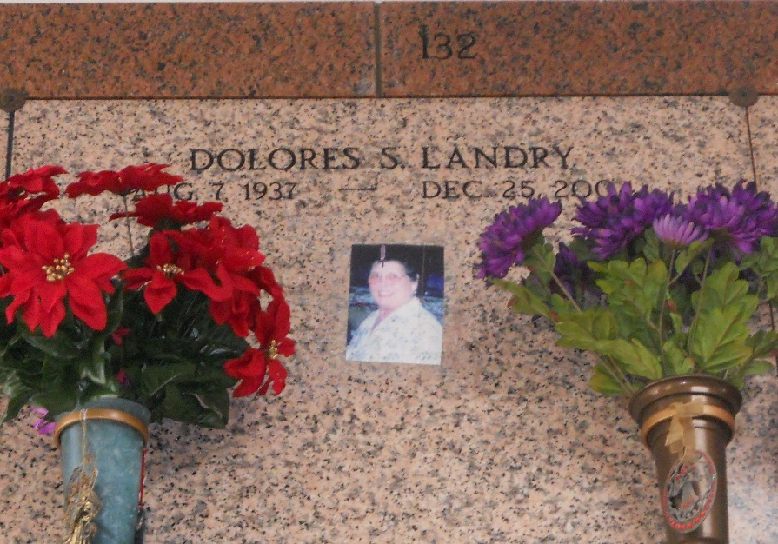
Photos by Team T-Lo

Dolores Schexnayder Landry On Saturday, December 25, 2004 At 8:53 Am. Age 67 Years. A Native And Life Long Resident Of Laplace, La.
Beloved Wife Of Percy J. Landry And The Late Nemoure Millet, Jr. Mother And Mother-In-Law Of Robert & Mary; Ronnie & Teresa; Donnie; Richard; Burton & Nicole Millet And Lisa Millet & David Poncia. Grandmother Of Kristen, Amanda, Joshua, Kaley, Alaina, Ethan And Shawn Millet. Sister Of Brenda Longaker, Gail Falterman, Delbert Schexnayder And The Late James Schexnayder. Daughter Of The Late Alfred And Malena Labranche Schexnayder.
Relatives And Friends Of The Family, Also The Ladies Alter Society, St. Joan Of Arc Thrift Shop And The Laplace VFW Auxillary Are Invited To Attend Services. Visitation At Millet-Guidry Funeral Home, 2806 W. Airline Hwy., Laplace, La. On Tuesday, December 28, 2004 From 9-11:45 Am. Followed By A Mass Of Christian Burial At St. Joan Of Arc Catholic Church 529 W. 5th St., Laplace At 12:00 Pm. Burial In St. Peter Church Cemetery, Reserve, La.

Times Picayune, New Orleans, Louisiana
December 28, 2004

