Eric Louis Landry
May 10, 1948 – August 18, 1971

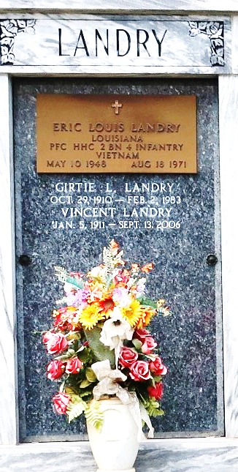

PFC Landry is one of 37 killed when their CH-47 Chinook exploded at about 1000 feet at a military training area near Pegnitz, Germany. They had departed Dolan Barracks and were headed to Grafenwohr training area. It was the worst U.S. military helicopter crash on record in Europe.
He is not included on the Vietnam Memorial because he was killed elsewhere.

Contributed by Bobby

