Ernest J. Landry
March 2, 1932 – June 11, 2007

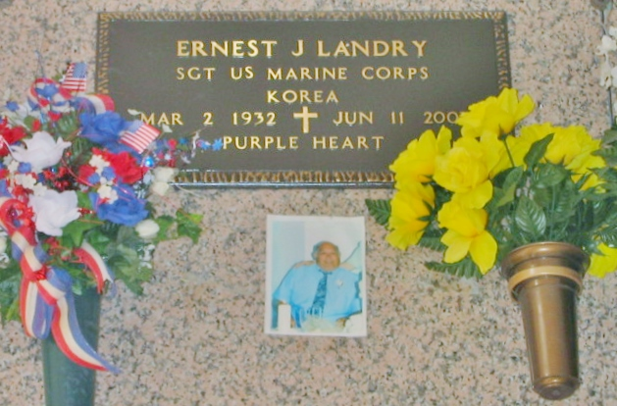
Photo by Bobby

Ernest (E.J.) Landry, on Monday June 11, 2007 at 5:50 p.m. Beloved husband of Marie Remondet Landry for 51 years. Father and father-in-law of Claudia and Danny Melancon, Vanessa and Glenn Chauvin, Greta and John Boudreaux, Samantha and Ken Usey and the late Ernest Landry, Jr. Grandfather of Darrin and Derrick Gaubert, Nicole Weber, Matthew Chauvin, Danielle, Jonathan and Emma Boudreaux, Colin, Madison and Bailey Usey. Great-grandfather of Dylan and Connor Weber. Son of the late Ernest and Marguerite Jacob Landry. Brother of Rosanna Galatas, Maurice, Grant and Brent Landry. Special cousin of Zelma Vicknair, Lee Jacob and the late Julius Jacob. He was a loving father and grandfather who participated in all of their activities.
He was a sergeant in the U.S. Marine Corps and served in Korea and received the Purple Heart medal. Age 75. A native and resident of Reserve.
Relatives and friends of the family, also Kaiser Aluminum, Reserve VFW, American Legion and The DAV, are invited to attend services. Visitation at Millet-Guidry Funeral Home, 2806 W. Airline Hwy, Laplace, on Wednesday, June 13, from 5 to 8 pm and on Thursday from 8 am to 9:45 am. Followed by religious services at St. Peter Catholic Church, Reserve at 10 am. Burial in church cemetery.

The Times-Picayune, New Orleans, Louisiana
June 13, 2007

