Heather Marie Landry
December 4, 1990 – July 7, 2020

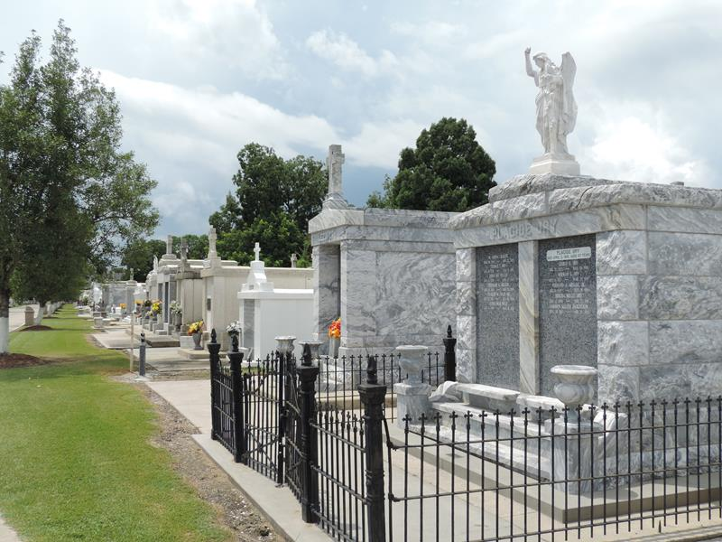

Heather Marie Landry, a native and resident of Reserve, passed away on Tuesday, July 7, 2020 at the age of 29.
She is survived by her parents, Guy and Doreen Landry; siblings, Albert Landry (Donna), David Landry (Barbie), Renee Landry and Chris Landry (Charlotte); fur-baby, Kamo and numerous relatives.
She is preceded in death by her grandparents, Eldon and Audrey Duhe and R.J. and Joyce Simoneaux.
Heather enjoyed spending time with her friends, crafting and cruising. She was very kind-hearted and loved children, especially her godchild Jaxon. She never met a stranger and loved talking to whomever she met. She was known to speak her mind. She will be greatly missed by all who knew her.
A visitation will be held at St. Peter Catholic Church on Saturday, July 11, 2020 from 9:00 AM until funeral time. A Mass of Christian Burial will be held at 12 noon. Interment will follow in the church cemetery. Masks are requested in the church.

Rose Lynn Funeral Services, Lutcher, Louisiana

