Lea Marie (Lambert) Landry
February 12, 1877 – April 27, 1949

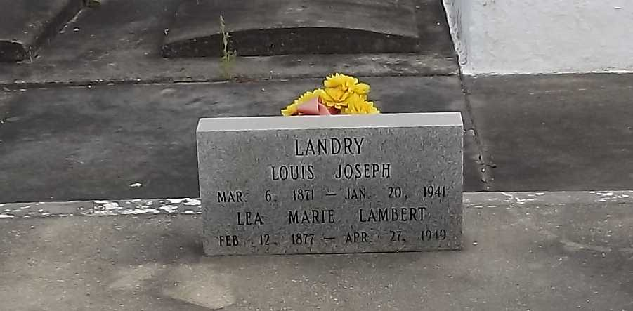
Photo by Mary Agnes Hammett

MRS. MARIE LEA LANDRY

Mrs. Marie Lea Landry, 72, of Norco, died today at 1:35 a.m. in Charity hospital, New Orleans, after an extended illness. She has been a resident of Norco for the past 25 years and was formerly of Garyville.
She is survived by four sons, Edward Landry of Baton Rouge, and Louis, Clay and Lionel Landry, all of Norco; two daughters, Mrs. Agnes Guidry, Norco, and Mrs. Olive LeJune, New Orleans; several grandchildren, nieces and nephews.
The body will be taken to Norco from the Rabenhorst funeral home this afternoon. Funeral arrangements have not been completed.

Unknown newspaper clipping

