Lelia (Bourgeois) Landry
September 14, 1887 – July 5, 1985

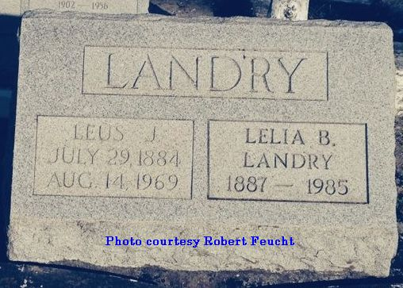
Contributed by Dwayne Montz

Lelia Bourgeois Landry died on Friday, 5 Jul 1985. She was the beloved wife of the late Leus Landry and the mother of the late Van Landry. She was the sister of the late Septime, Numa, Aloysius, Anicet, Eleanor, Leonie, Achille and Leonce Bourgeois, Aurelie B Schexnayder, Aline B Vicknair, Marie B Polizzoto and Olympe B Ford. She is survived by her daughter-in-law, Ollie Hebert Landry, and many nieces and nephews.

She was age 97 years, a native of Mt Airy, Louisiana, and a resident of Lutcher, Louisiana, for 71 years and of Bunkie, Louisiana, for the last 9 years.

Mass of Christian Burial will be at St Joseph Church, Paulina, Louisiana, with interment in St Peter Cemetery, Reserve, Louisiana.

The Times-Picayune, New Orleans, Louisiana
7 July 1985

