Leus J. Landry
July 29, 1884 – August 14, 1969

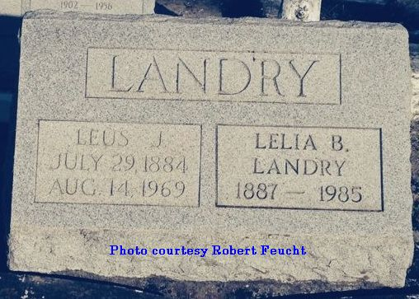
Contributed by Dwayne Montz

Leus J. Landry died Thursday 14 Aug 1969 at 8:20 a.m. at age 81 years. He was the husband of Lelia Bourgeois Landry and the father of Van Landry of Bunkie, Louisiana. He was the brother of the late Leonce, Lazard and Provosty Landry Jr, Mrs. Rudolph Hebert, Mrs. Theo Poche and Mrs. Prudent Decareaux. He was a native of Ascension Parish and resident of Lutcher, Louisiana.

Relatives and friends of the family are invited to attend the funeral from Alexander Funeral Home, Lutcher, on Saturday 16 Aug 1969. Religious services at St Joseph Church, Paulina, Louisiana, with interment in St Peter Cemetery, Reserve, Louisiana.

The Times-Picayune, New Orleans, Louisiana
August 15, 1969

