Marcelle (Montz) Landry
November 5, 1906 – February 25, 2002

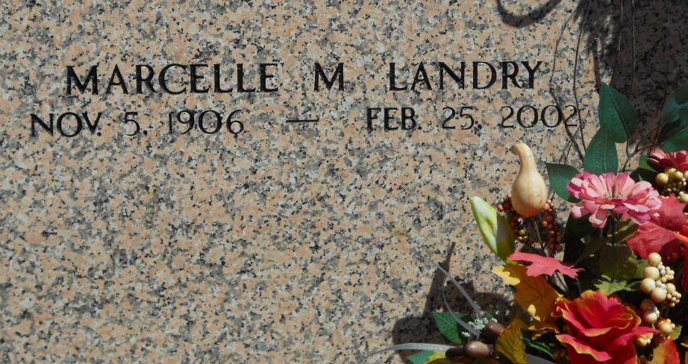
Photo by Team T-Lo

Marcelle Montz Landry, On Monday, February 25, 2002 At 6:10 A.M. Age 96. A Native And Resident Of Reserve.
Beloved Wife Of The Late Clifford Landry. Mother Of C.F. Jr., Ronald, Bobby, Richard And Roy Landry, Leatrice Luminais, Mary Gay Catoire, Sylvia Simoneaux, Sybil Montegut, Irene Moore And The Late Mickey Landry. Daughter Of The Late Pierre And Marie Montz. Sister Of Mae Keller, Carl Montz And The Late Pierre Montz, Jr., Eleanor Montz, Juliet Bressler And Denise Bourg. Also Survived By 29 Grandchildren, 46 Great-Grandchildren And 4 Great-Great Grandchildren.
Relatives And Friends Of The Family Are Invited To Attend The Funeral Services At St. Peter Catholic Church Reserve On Tuesday, February 26, 2002 At 11:00 A.M. Burial In Church Cemetery. Visitation From 9:00 A.M. On Tuesday At The Church Until Services. Arrangements By Millet Guidry Funeral Home,. Laplace.

The Times-Picayune, New Orleans, Louisiana
February 26, 2002

