Melvin Joseph Landry
December 16, 1923 – March 18, 2017

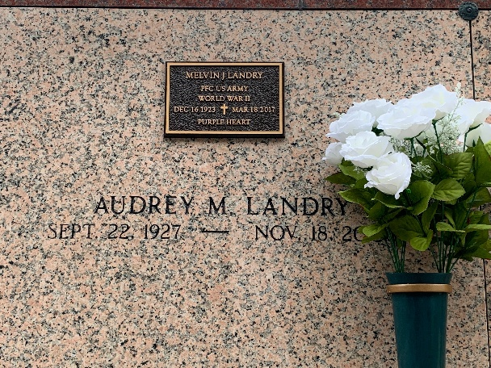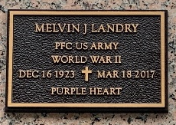
Photos by Team T-Lo

Melvin Joseph Landry passed away on Saturday, March 18, 2017 at the age of 93. He was a native of Reserve, LA and longtime resident of Garyville, LA.
Melvin proudly served his country in the U.S. Army during W.W. II in the invasion at Normandy. He was a lifetime member of the VFW Post in Reserve, American Legion in Reserve and Disabled American Veterans. He later retired from Godchaux Henderson Sugar Refinery in Reserve, LA.
Beloved husband of the late Audrey L. Landry. Loving father of Pamela Landry Lemoine (Lenny Sr.) and the late Baby Landry. Grandfather of Sarah Lambert Adams (Steven) and the late Michelle Lambert. Great-grandfather of Morgan Adams and Brooklyn Adams. Step-grandfather of Lenny Lemoine Jr. (Elke). Son of the late Marguerite Tassin Landry and Donat Landry. Brother of Whitney Landry (Alberta), Percy Landry, Dorothy Durapau, Shirley Nicholas (Gerald) and the late William Landry, Helen Perkins and Elsie Jacob. Also survived by many nieces and nephews.
The family would like to give a special thanks to the staff, especially Unit 4, of the Southeast Louisiana War Veterans Home for their compassion and care.
Relatives and friends are invited to attend the visitation at Millet-Guidry Funeral Home, 2806 W. Airline Hwy, LaPlace, LA on Wednesday, March 22, 2017 from 5:00 p.m. to 8:00 p.m. and on Thursday, March 23, 2017 from 9:00 a.m. to 11:00 a.m. with the Funeral Mass to immediately follow at 11:00 a.m. Interment in St. Peter Cemetery. To view or sign the online guest book, please visit Millet-Guidry Funeral Home.

The New Orleans Advocate, Louisiana
Mar. 20 to Mar. 22, 2017

