Michael Paul Landry
November 5, 1955 – May 15, 2022

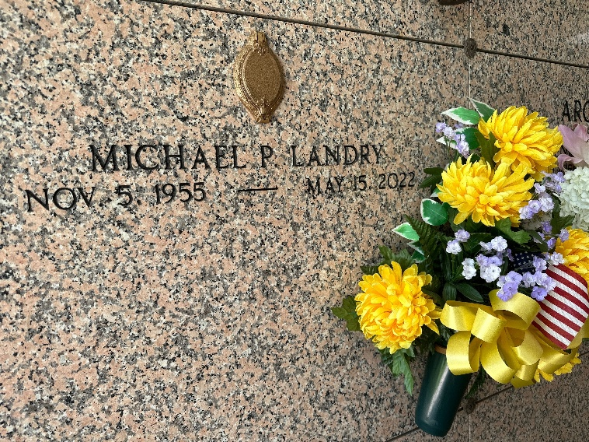
Photo by Team T-Lo

Michael Paul Landry passed away on Sunday, May 15, 2022 at the age of 66. He was a native and a lifelong resident of Reserve, LA.
Beloved son of Hazel Boe Landry and the late Clifford Francis Landry. Brother of Barry J. Landry (Jeri).
Michael retired from St. John the Baptist Parish after 26 years of service. He enjoyed making bird houses and will be missed by all who loved him.
Relatives and friends are invited to attend the Visitation and Funeral Service at St. Peter Catholic Church, 1550 Hwy 44, Reserve on Friday, May 20, 2022. Visitation from 9:00 a.m. to 11:00 a.m. followed by a Funeral Mass at 11:00 a.m. Interment in St. Peter Cemetery.
Millet-Guidry Funeral Home, LaPlace, Louisiana
May 18, 2022

