Nettie (Broussard) Landry
May 27, 1876 – June 5, 1958

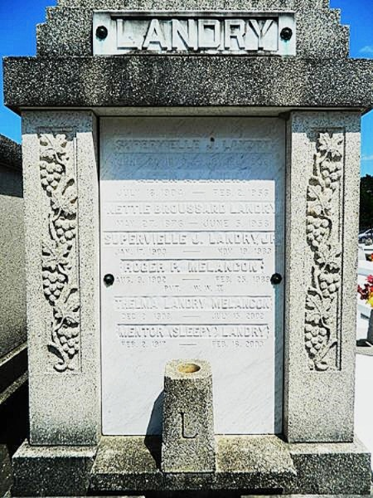
Photo by Team T-Lo

Nettie Broussard Landry died at her residence in Laplace, Louisiana, on Thursday, 5 Jun 1958 at 2:00 pm at age 83 years. She was the wife of the late Superville J Landry and mother of Mrs. Eugene H Payne of Jackson, Mississippi, Mrs. Roger Melancon of Laplace, Mrs. Clarence Brignac of Good Hope, Louisiana, Mrs. Emile Rausch of New Orleans, Superville J Landry Jr and Mentor Landry of Laplace and the late Alton (Buddie) Landry. Also survived by four grandchildren.
Services were Saturday 7 Jun 1958 at St Joan of Arc Church, Laplace, with interment in St Peter Cemetery, Reserve, Louisiana.
The Times-Picayune, New Orleans, Louisiana
7 Jun 1958

