Robert Joseph Landry Sr.
July 23, 1934 – November 18, 2012

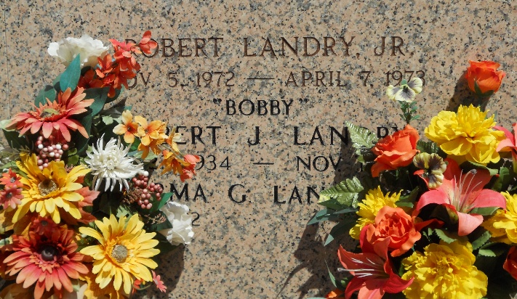
Photo by Team T-Lo

Robert J. (Bobby) Landry went to meet the Lord at 7:10pm on Sunday November 18, 2012. Beloved husband of Irma Guedry LeBlanc Landry. Father of the late Robert Landry Jr. Step-father of Terry LeBlanc. Son of the late Clifford and Marcelle Montz Landry. Brother of Roy Landry, Leatrice Luminais, Mary Gay Catoire, Sylvia Simoneaux, Sybil Montegut, Irene Moore and the late Clifford (C.F.) Jr., Ronnie, Mickey and Richard Landry.
He was an Army Veteran of the Korean Conflict and a self-employed painter. Age 78. A native and resident of Reserve, LA.
Relatives and friends are invited to attend services. Visitation at Millet-Guidry Funeral Home, 2806 W. Airline Hwy. LaPlace, LA on Tuesday November 20, 2012 from 5:00pm to 9:00pm and on Wednesday from 8:00am to 9:30am, followed by Mass at St. Peter Catholic Church, Reserve, LA at 10:00 am. Burial in St. Peter Cemetery.
The Advocate, Baton Rouge, Louisiana
November 19-20, 2012
Contributed by Judy LeBlanc Bercegeay Babin

