Supervielle Joseph Landry Sr.
June 23, 1874 – November 28, 1938

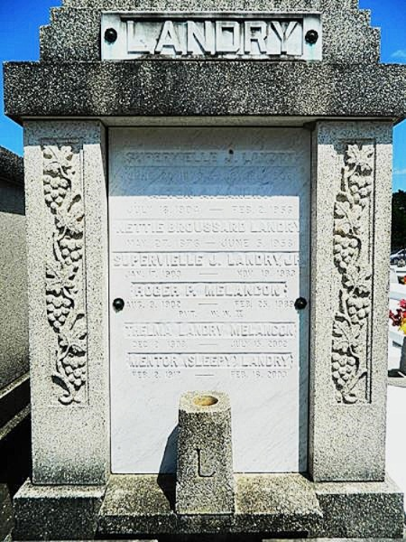

Supervielle Landry died Saturday 19 Sep 1983 at 8:10 pm at age 80 years. He was a native and resident of Laplace, Louisiana, and the brother of Mrs. Ugene Payne, Mrs. Roger Melancon, Mrs. Clarence Brignac, Mrs. Emile Rausch and Mentor (Sleepy) Landry and the late Alton Landry.

Services were Monday 21 Nov 1983 at St Joan of Arc Church, Laplace, with interment in St Peter Cemetery, Reserve, Louisiana.
The Times-Picayune, New Orleans, Louisiana
21 Nov 1983

