Wilda (Stogner) Landry
November 17, 1942 – May 21, 2008

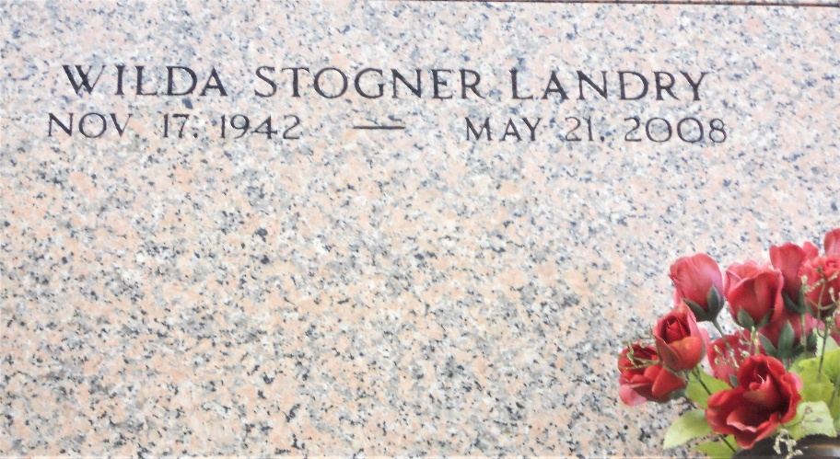
Photo by Team T-Lo

Wilda Stogner Landry on Wednesday, May 21, 2008 at 10AM. Beloved wife of Bernie Landry. Mother of Theresa Melancon, Ursule Melancon and Huey Melancon, Jr. Daughter of the late Hollis and Maudine Stogner. Sister of Wilton, Jewel, Sedgie and Kenzie Stogner, Nell Blackman and Mildred Frank.

Age 65 years, a native of Mississippi and a resident of Garyville, LA for the past 4 years.
The Times-Picayune, New Orleans, Louisiana
May 23, 2008

