Joyce Marie (Keller) Lapeyrolerie
Abt. 1935 – May 26, 2018

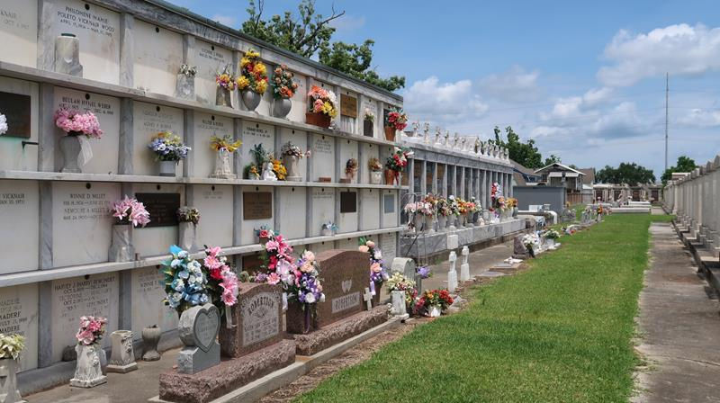

Joyce Marie Keller Lapeyrolerie, 83, formerly of Reserve, peacefully passed the morning of May 26, 2018, in Austell, Ga.
A lifelong Catholic, she was baptized at St. Peter Catholic Church and was blessed to receive the final sacrament. She was predeceased by her husband of 27 years, Raymond Lapeyrolerie; parents Henry and Elsie Keller; brothers Allen Keller and Calvin Keller and sisters-in-law Lula Belle Borne Keller, Alice Keller and Toinette Keller. She is survived by her only daughter Tricia (Rodolfo) Lapeyrolerie Hernandez of Douglasville, Ga.; two sons: Burnell Lapeyrolerie of Austell, Ga., and Michael (Tonya) Lapeyrolerie of Mableton, Ga. She was blessed with eight grandchildren whom, she adored; Lamar (Shineka) Karim, Chelsea (Jakeem) Lapeyrolerie Sheffield, Demetrius Owens, Christian Hernandez, Michael Sevion Lapeyrolerie, Javier Hernandez, Dominque Lapeyrolerie and Nazir Hernandez. She is also survived by her beloved younger brother, Frank Keller, and many nephews, nieces, family members and friends.
Joyce was a graduate of Fifth Ward High School and Southern University Baton Rouge, where she earned a Bachelor of Arts in Elementary Education. She enjoyed a long and successful career as an elementary school teacher of the St. John the Baptist Parish school system for over 20 years. In 1995 she relocated to Atlanta, where she resided for the last 23 years.
Relatives and friends are invited to attend the Memorial Mass celebrated at Our Lady of Grace Catholic Church located at 772 Highway 44 in Reserve on Wednesday/June 6 at 10 a.m. Visitation will begin at 8:15 a.m. followed by the recitation of the Rosary at 9:15 a.m. Interment is at St. Peter’s Cemetery in Reserve. Cards can be mailed to 3800 Lindsy Brooke Court in Douglasville, Ga., 30135, c/o Tricia L. Hernandez. Masses celebrated in her honor will also be appreciated. Knox Funeral Home of Atlanta is in charge of arrangements.

L'Observateur, LaPlace, Louisiana
May 31, 2018

