Tony Jules Lapeyrolerie
March 3, 1940 – October 23, 1994

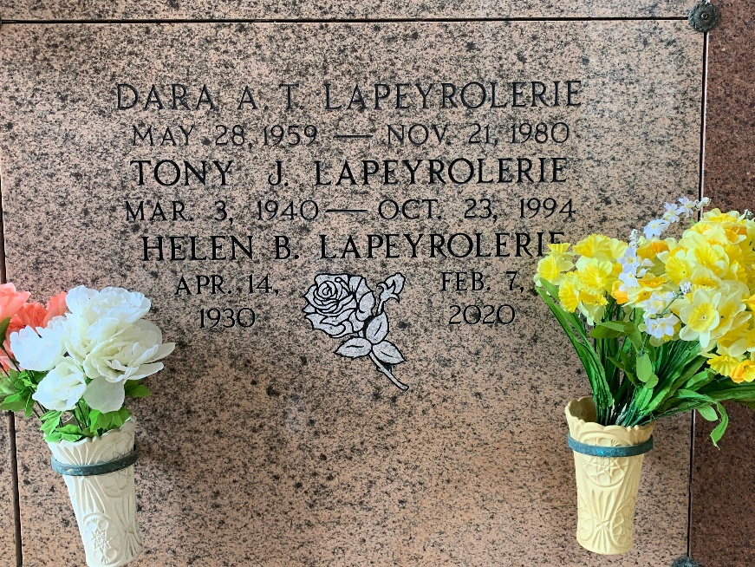
Photo by Team T-Lo

Tony Jules Lapeyrolerie, A Welding Foreman, Died Sunday At East Jefferson Hospital Of Injuries He Suffered In A Job Accident. He Was 54.

Mr. Lapeyrolerie Was Born In Edgard And Lived In Reserve For 35 Years. He Was A Member Of The St. Peter Catholic Church Choir.

Survivors Include His Wife, Helen Beauchamp Lapeyrolerie; Two Daughters, Demetra Derouen And Brenda Thornton; His Mother, Nellie Pierre Oubre Lapeyrolerie; His Father, Gayle Lapeyrolerie; And Three Grandchildren.

A Funeral Mass Will Be Said Saturday At 11 A.M. At St. Peter Catholic Church On River Road In Reserve. Visitation Will Be Friday From 7 P.M. To 10 P.M. At Robottom Mortuary On River Road In Reserve. Recitation Of The Rosary Will Be At 8 P.M.

Times Picayune, New Orleans, Louisiana
Friday, October 28, 1994

